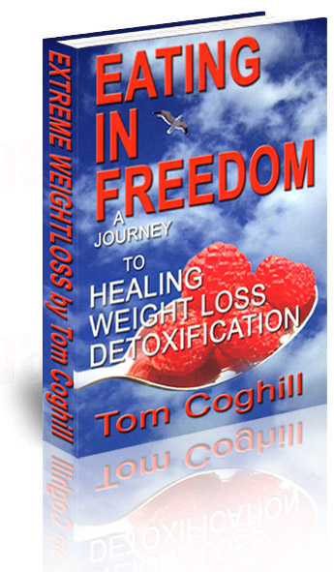

Copyright
Eating in Freedom by Tom Coghill. Copyright © 2000 and all rights reserved. Parts of this manuscript may be photocopied and quoted—providing the content is not distributed, is unchanged, and no profit is incurred. All scripture quotations are from The Holy Bible, New International Version (NIV). Copyright © 1973, 1978, 1984 International Bible Society. ISBN 1-896802-08-7

The procedures in this manuscript are based on the research and personal experiences of the author. Each person and situation is unique and the publisher urges the reader to check with a qualified health professional before using any procedure where there is any question as to its appropriateness.
To order other books visit
www.fasting.ws

Other books in the series
The Perfect Diet (manuscript format): Knowing the truth about food is essential to change. North American Diet strips away the glamour of fancy packaging and examines the destructive nature of our modern diet: chemical additives, carcinogens, tetragons, trans-fatty acids, saturated fat, preservatives, stabilizers, emulsifiers, food colors and artificial flavors, forever changing how you feel about Ronald McDonald's happy meal.

Fasting (5” x 8.5” 164 pg): Imagine dropping 20 pounds and 20 years from your life while discovering gifts, abilities and youthful vision that have been locked up inside of you for so many years. Fasting to Freedom provides all the information you need to safely fast on juices, and it gives you many juice recipes you will need for juicing. There is information on the specific, rejuvenating qualities of a variety of fruits and vegetables, and we look closely at both the physical and spiritual blessings of fasting. The information that is provided in this manuscript helps you to make wise, lifelong choices.

Extreme Health Recipes (6” x 9” 265 pg) finally, you can have the best of both worlds: delicious flavor and vital health. From picking perfectly ripe fruit to preparing savory vegetable broths, God's Banquet Table provides everything you need to know, and it contains a variety of vegan-vegetarian recipes that the whole family will love.

Introduction

It was an accident. I never intended to walk down the cookie aisle. I was really heading over to the vegetable section for lettuce. But there they sat, so innocently: President’s Choice Chocolate Chip Cookies, my favorite! I could feel the twinge of anticipation as I lay them in the shopping cart. Five hours had passed. Now the kids were in bed. The anticipation grew to urgency. I grabbed the cookies from the shelf. My cozy space was ready. I had moved my well-worn chair into place, positioned the tray on the left side of the chair, found the converter, poured the coke over ice into my favorite mug. I flipped on the TV; then with a sigh of great happiness, I sat back to enjoy every bite.
It was a short, empty experience. I felt cheated. Now I sit with nothing left but cookie crumbs and a chocolate aftertaste. As always, here comes the guilt to ruin the fun. I try to rationalize, but the voice of guilt is relentless. I sit in the dark, wondering if I will ever be able to become that mythical me that I see only in my dreams — thin, young, healthy and free.
The problem is, as of late, it is becoming harder to dream.

TABLE OF CONTENTS

1 FOOD WAR....….......……………..............….……..5
A look at the modern Eden, fed by a corrupt food industry, profiting on emotional pain. How we become obsessive with food. A look at the distorted thinking that ruins self-discipline. How the subconscious affects our behavior.

2 HAUNTED BY THE PAST..….....…………...….10
How the past affects our self-image, thoughts and self-discipline. Facing fear as the doorway to freedom.

3 KILLER CRAVINGS.............….…….....…….…..12
A scientific look at food addiction and how we form triggers and cravings. A study of the neurotransmitters that are the force behind compulsive behaviors.

4 BUILDING DISCIPLINE....…....……….…..........16
How to build self-discipline that will overcome compulsive, obsessive behavior. How to form life changing decisions.

5 THE CRAVINGS DEFENSE SYSTEM………….19
A method of dealing with cravings and negative thoughts.

6 BRAIN BATTLEFIELD..….……….....………..….22
Learn how to fight cravings with self-encouragement.

7 BECOMING YOUR OWN CHEERLEADER…..24
A list of encouraging statements to fight fear, worry and build enthusiasm.

8 GOD'S COMMERCIALS.......………….….…..….26
The power of visualization and how our imagination can give us success over dieting. Includes relaxation and visualization techniques.

9 YUCK POWER........……………........….….......…...30
How revolting thoughts and images can stop obsessive thinking. A powerful, yet simple and easy-to-use technique.

10 THE DOPAMINE DIET PLAN......……..…….….....33
How we can use the pleasure of dopamine to form healthy behaviors and eat better.

11 FACING FAILURE........……………...…...…...........37
Overcoming the pain of failure. Rebuilding self-confidence and determination after blowing it on a diet. How to fight guilt and self-defeating thoughts. How to prepare for failure.

12 ESCAPING THE RUT...........….….…………….........43
Inspirations to develop a challenging routine that will overcome the overeating rut. Simple methods to break the continuous cycle of overeating by using every-day activities.

13 GOD POWER.........……….....….…...….………….....48
The spiritual aspect of indulgence and how to combat it with prayer, commitment to God and positive affirmations from the Bible.

14 QUIT DAY…....………….….........….………......…......51
Preparing the mind for quit day. Getting started checklist. Making a bad food hit list.

15 WHAT TO EAT............……….......…..…...……….….53
An explanation of the physical effects of eating more raw food and reducing calories including detoxification and the healing effect of raw foods.

16 HOW TO EAT...................…..…………...…….……....56
Ways to make eating healthy and more enjoyable so that it will become a natural part of your lifestyle.

17 THIRTY DAYS TO FREEDOM.……………..…........58
30-days period of controlled eating with lots of raw fruits and vegetables to establish discipline eating. Raw food helps to rebalance the body and cleanse toxins, which assists the body recover mental and emotional balance.
18 RECIPES..................….......….…..……………...……...65
Fun, easy-to make recipes.

BIBLIOGRAPHY………........……….…………….……....70

Chapter 1

Food War

Wouldn't you love to feel super healthy? Imagine your body bursting with vitality, every cell fed with nutrient-rich food. Adam and Eve had it easy — two kids in paradise, eating from a banquet of exotic, tropical foods, living stress-free, naked in the sunshine with God as their best friend. No cooking, no dishes, no worries, only health, joy and freedom. What an awesome life!

Adam and Eve had never been to McDonald’s. To them fast food was a succulent mango or a juicy pear. They were surrounded by sun-ripened nutrition, ready for the picking. A perfect diet, low in fat, cholesterol-free, toxin-free, abundant in enzymes, minerals and vitamins. Every cell sang a song of joy to an amazing Creator, a Provider who cares for every need with love and understanding.
Here in the 21st century, there are no sun-drenched garden paths with dangling fruit. Instead, there are florescent-lit aisles of cans, boxes and bags, set out by a corrupt food industry, a provider driven by greed for money, ruthlessly using addiction for profit. Fat, sugar, salt and additives are the tools of the trade. Bodies riddled with cancer and heart disease are of minor concern.
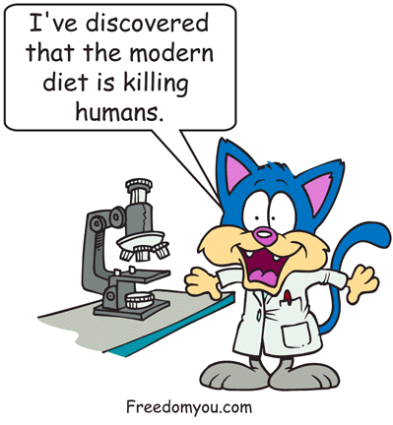
Once addicted, it's hard to say “no.” The body craves foods that are harmful. Try to improve your diet, and cravings pop up everywhere.
Some people fight battles with guns and tanks; others use spoons and kitchen utensils. I remember the Battle of the Bulge. The Ponderosa Salad Bar suffered a six-plate defeat. I remember a war with a chocolate Easter bunny. In the middle of the night, I bit its head off. I admit it. I was a food addict. My life was controlled by food. Moderation was never my strong point. When it came to ice cream, one scoop was never enough. I once ate a two-and-a-half gallon tub of maple walnut ice cream. It almost froze my stomach. To make matters worse, it was my roommate’s ice cream! I felt so badly afterwards that I put a 12-foot chain through the handles of the refrigerator and cupboards and told my roommate, “here's the key to your food.” He wasn't impressed.
It's not that I was overweight. I was thin because God had blessed me with a fast metabolism. I desperately wanted to eat nutritiously to help heal the damage from drug abuse. Although I had gotten free from drugs, I felt weak and sick. The only way I felt better was to eat a light diet, but the more I tried not to think about food, the more obsessed I became. I would stop eating cookies for three weeks, eat one cookie, and then relapse with a cookie binge. No cookie was safe from me. In minutes, a bag would be reduced to crumbs. If it wasn't cookies, it was chocolate. I became a chocoholic with a $28-a-day habit. I could drive only short distances, as I would have to stop every 15 minutes for a chocolate fix. Mornings were hell. There is nothing worse than a cocoa bean hangover. After hating myself for being so weak, I'd make a decision to stop, only to take another beating from Mr. Big®.
Reading the Bible, I was amazed at the discipline of the Apostles. They were focused, resolute, persistent and patient. Meanwhile, I couldn’t win a battle with a peanut butter cup. In hand-to-mouth combat, I would come out a loser. I so wanted to be like those men of God!
I needed discipline. So off to the gym I went, dragging a drug-abused body through the paces. Little by little, discipline developed. I could even juice fast and my body was starting to feel much better, but in the area of diet, I was still battling with food. I felt out of control.
The battle within my soul went on for many years, sometimes achieving victories over my compulsive behavior, only to fall again. And how I fell! Compulsion, obsession and addiction carry a stiff price. But just when all seemed hopeless, understanding came.

Food Junkies
It is our heart's desire to eat nutritiously and to be healthy. Yet, in spite of our desire, we follow a different path: the one to the refrigerator. A magnetic cherry cheesecake appears and pulls us closer. “No I shouldn't,” we sigh, as if being dragged against our will. We fight its control, but the cheesecake knows that eventually we will surrender.
Bulging bellies and heavy hips are not enough to drive us away from those fatty, sugar-filled foods. High blood pressure, diabetes, heart disease and looming health conditions are not enough to repel us. Like a moth to a flame, we stand mesmerized by a 40-watt refrigerator light. No hunger to satisfy, just a pleasure junkie looking for a fix.
Throwing all restraint aside, we have filled the bloodstream with fat, cholesterol, toxins, additives, and preservatives, consuming foods with no nutrition, expecting our bodies to quietly endure the barrage without the consequences. But, a pleasure-centered diet has a price. Disease and obesity are the plague of the 21st century. Surgery and chemical medicines have become the Band-Aid for a problem caused by inner pain and emptiness.
Desperation seeks hope in diet programs, liposuction, breakfast shakes, exercise, breathing techniques, stimulants, weight-loss drugs, hypnosis, plastic wraps, creams, vibration machines and electric muscle stimulation — more Band-Aids. Most of these techniques fail because they cannot relieve the aching of a soul crying for food to soothe the pain.
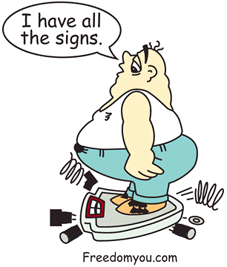Does God want you to suffer? No! He came to set us free. Free from the past. Free from guilt, depression and sin. Free to be a child before an amazing God Who loves us. But we are not living free. If we honestly evaluate our decisions and actions, we will face the sobering realization that our emotions are in the driver's seat. Feelings compel us to act. When they become uncontrollable, they are defined as compulsive, obsessive or addictive behavior.

Signs of Compulsive Eating
- Thinking about food a lot.
- Eating to relieve worry or stress.
- Continuing to eat even after feeling sick from eating too much.
- Becoming anxious while eating.
- Daydreaming or worrying while eating.
- Overeating.
- Eating too fast.
- Eating everything on the plate.
- Feeling guilty when you eat.
- Eating in secret.
- Unable to eat one cookie or any treats that you really like.
- Bingeing after a diet.
- Hunger makes you feel fearful and uncomfortable.

Fixed on Food
Rebellion is an ugly part of the human character. Tell a rebellious kid not to do something and sure enough, he will do it. We don't like to be told what to do (or what not to do). When we tell ourselves, “I will not eat that cake,” another defiant voice answers, “You're not telling me what to do.” Then the battle starts between the ears. Trenches are dug. The side of selfish indulgence stubbornly hangs on to the desire to eat cake. It hears some great propaganda messages like “I deserve it. One slice won't hurt.” We start to feel deprived. Precious pleasure is being taken away and we feel hurt. Emptiness and pain well up, resolve weakens.
We want to run from the pain into the comfort of food. Anticipation is revved to full power with a single focus . . . cake. Emotions redline on adrenaline ready for the impulse to bite. The side of self-control is desperate: “don't think about those delicious chocolate flavors.” But it's too late. The battle is lost!

Pink Elephant

Obsessions
Think of a huge floating pink elephant. Now that you have the image in your mind, stop thinking about it. Now, take a break from reading and for one minute; do not think of it. Think of anything else but that floating pink elephant.
Trying not to builds the desire, forcing you to think of nothing but pink elephants. Keep trying not to think of them and you will become obsessed with pink elephants.
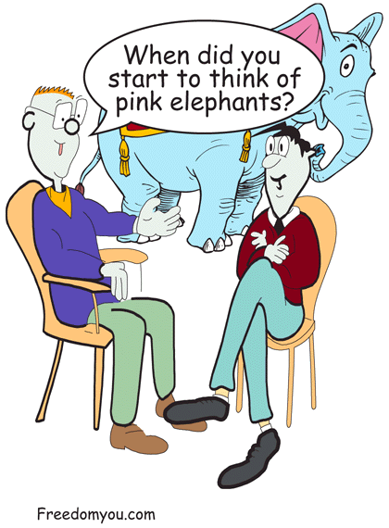
We create powerful obsessions with food by trying not to eat certain foods. The more we try, the worse it gets. Eventually, the only thing filling our minds will be the thought of that pizza and pop, or whatever we are trying not to eat.
You have trained your mind to think obsessively. As kids, we ate when hungry and stopped when satisfied. By adulthood, we deteriorated into pleasure-centered food addicts.

Distorted Thinking
Compulsive eaters are the first to admit that we are living in a mental mess. Life is a series of worries and frustrations. Our emotions are controlled by outside events. We fail by eating one cookie and confidence plummets. Feeling hopeless, we completely give up and throw off all sense of restraint. Then comes the feeling of failure:

“I am a failure.”
“Everything I do fails.”
“Life is the pits.”
“I shouldn't, but...”
Psychology calls it abstinence violation effect, the psychological reaction to violating a vow of abstinence. Simply said, the effect is a feeling of failure. And for some, failure is devastating.
After failure comes guilt. Guilt never works, but we use it anyway. We beat ourselves with guilt in a feeble attempt to whip a tired, weary soul back to the battlefield. But the soul groans in defeat, “I have had enough. I don't care about this stupid diet.”
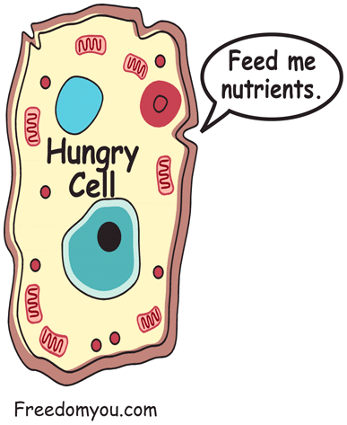
Why is it so hard? Why is it so difficult to eat a little less? After all, we desperately want to eat right. It is our heart's desire. We want to be thin, healthy, full of life, looking great and living life to its fullest. But instead we throw it away for 20 seconds of taste-bud pleasure.

Subconscious
The brain weighs only a few pounds, but it is hundreds of times more powerful than the fastest computer. Within the brain's deeply furrowed cortex lies a wellspring of memory, dreams, alertness and self-awareness. Neurons hum with activity — networking, processing, and acting with lightning speed to interpret the messages from the sense organs. The temporal lobe, association cortex, corpus callosum, and the left and right hemisphere act like players in an orchestra to transform the constant influx of signals into a cohesive interpretation of the inner and outer world.
Even with today’s high-tech diagnostic tools, the brain is like an iceberg—hiding more than we can see. Below the surface are the workings of the brain hidden from the conscious. It's called the subconscious. It does most of the work you take for granted.
Imagine trying to walk while figuring out what blend of digestive juices your pancreas needs to digest the pizza that you ate for lunch. Imagine sending millions of enzymes, one by one, into that sticky, half-digested pizza sludge looking for a nutrient. Meanwhile, your heart needs regulating and you're getting a little confused in organizing the 100,000 chemical reactions the mind performs each hour to maintain homeostasis (balance). And you thought making your eyes rotate in two different directions is hard! If these reactions were not hidden from us, we could not function. Automatic functions let our brain focus on the most important things.
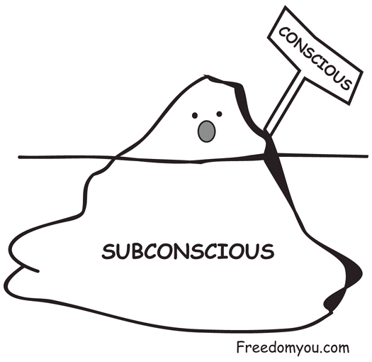
To develop any skill, we train our bodies to react, then refine that reaction so we gain control with ever-increasing complexity. A concert violinist plays with ease because he has developed a complex array of automatic reactions. It is much like writing a program for a computer.
Consider the brain a bio-computer and you, its haphazard programmer. You have been inputting data and setting up programs since childhood. Every smile, criticism, kind word and insult is a source of data. But much of that data was false. Through corrupted data, you may have come to believe that you are clumsy, useless, hopeless, fat, ugly, stupid, weak and cowardly. Those beliefs have determined your actions and powerfully affected your thinking process. Each distorted thought has entered the subconscious, stirring waves of emotion, shame, guilt, fear and rejection, each wave adding to the overwhelming feeling of worthlessness. A feeling that shouts, “you are a failure!”
It is easy to give up. You don't have to try when you believe that you’re going to fail. But when you give up you feel helpless, empty, and want relief. The food industry is ready to profit from that emptiness.
The diet industry has spent millions on putting a Band-Aid on a symptom. Our bodies are sick and overweight because our minds are filled with toxic thoughts that destroy self-worth, motivation and discipline.
We come to believe our problems with negative emotions are psychological. We may even seek medical cures. Minor results come, but most of the time we are discouraged. If you have been controlled by food, thinking obsessively and battling through each diet, you will find freedom. It will take work, but there will be no waiting for results. Everything you will learn in the following pages will increase your self-control by assisting you in disciplining your thought life. This understanding will help you gain control over not only your diet, but also many other areas of your life. As you start to feel more secure, your defenses will fall away, and you will feel the presence of God. There will be times when you will feel immersed in the comfort of peace. You will feel love in a way that you have never known. You will become emotionally stable. Discipline will be seen in the little things. You will smile easily, share willingly, laugh readily, enjoy life, have enthusiasm, and most of all, you will have a sense of joy and a feeling in the quietness of your soul that says... “All is well.”
Sounds too good. Like a miracle? Give your body a few weeks on a light diet of fruits and vegetables and amazing things will happen. Cells regenerate, the skin softens and veins are cleansed. The lymph glands, liver and kidneys detoxify as you experience the awesome wonder of healing.
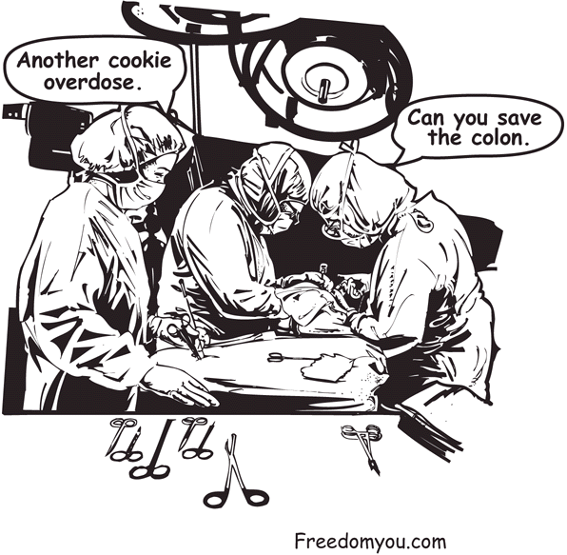
Just as the body can recover from disease, the mind can also recover. God can heal emotional wounds, patterns of obsession, compulsion and addiction. But only if you fill your mind with encouragement. You have let your mind run its random course, only to find emotional pain that steals your self-control. It is time to recover your mind and let it be renewed.

Chapter 2

Haunted

by the Past

Diets have a nasty habit of stirring up the past where all those painful memories live. When awakened, they crawl up the subconscious tunnel to poke holes in our self-worth. As we pull away from the comforting security blanket of food, we face the emptiness of our soul.
Job stress, family pressures, health conditions, worry and negative thinking intensify childhood pain. Life becomes a tangle of painful emotions, and dieting tugs on the string of that tangle. One pull and the soul says “Ouch! Don't mess with this stuff, it hurts.”

On the surface, people may see you as a successful individual, but beneath there are painful issues that have never been resolved. If these issues are causing a desperate desire to escape through food, then no diet pill or exercise program will solve the problem. Dieting may work for a time, but eventually you’ll only have to face the pain of failure.
Addictive/compulsive behavior is a desperate attempt to find peace in an emotional storm of insecurity, disappointments and childhood pain. In that storm, it is impossible to maintain the focus needed for self-discipline. Like trying to rake leaves in a windstorm, the mind changes direction with every emotion that blows through. To gain self-control, you need to calm the winds of insecurity that are driven by distorted, negative thinking. You need to calm the storm and be at peace.

Getting Past the Past
Life is 10% what happens to you and 90% what you do with it. You may have been abused, insulted, faced illness and loss, but you can overcome the past. Bad things happen, and we can't change that. But we can change the future. It is time to leave the past in the past and get on with life. It is time to stop feeling like a victim.
Depression is a pity party, anger only hurts you, resentment seals out love, and worry fixes nothing. Distorted thoughts get distorted results. Set your mind to what you can do, and then do it. Encourage yourself. Take action and your emotions will come into line; those painful memories will fade in the light of joy.
Eating is the easy way out, a dependable source of pleasure and comfort. An aching soul is eased for a few moments, but the emptiness and pain quickly return. Food can't fix the past, but Christ can. With God, nothing is impossible. (Luke 1:37) He heals the broken hearted and binds up their wounds. (Psalm 147:3) Face your fear, because you have nothing to fear. When God is for us, who can be against us? When depression raises its ugly head, scorn it. Feelings are unscrupulous salesmen selling you something you don't want. Don't buy it. Look only at the facts. Why are you feeling this way? Get the points written on paper and look at them objectively. Is it really as bad as it feels? Emotional issues are tiny battles you need to win. Make your decision, then stand by it. Do what you can, and leave the rest in God's hands.
Run from fear and it will become more frightening. Run from a problem and it will grow into a Goliath. You are ready for the challenge. Face your Goliath with courage. Face it and overcome it. Face your fears and insecurities and your pain will turn to freedom and joy.

Facing The Past
This world is not fair. You can't change that, but you can choose to live life to its fullest. You can take the good and leave the bad. Bad things happen to everyone. No one has a perfect childhood or perfect parents. You may feel shame, guilt, anger or resentment over what happened in your childhood, but you can let it go. You can accept the pain. The pain is real. You were hurt. Grieve the loss and move on to your future.
The past is unchangeable. Accept what has happened to you. Forgive, then make the decision not to let the past control your life. Yes, people have hurt you. Be glad that you are not like those people. We each reap the seeds that we sow. They will reap their seed, and you will reap yours. Be glad you are a kind person in spite of the abuse. You have become a better person, deeper, more compassionate, with more understanding. Encourage yourself, for you have come a long way!
Change how you think, and you will change how you feel. Events are not destroying your happiness, but the negative thoughts about you are destroying it. You have a distorted image of yourself. You may believe that you deserved being hurt because you were so bad. Because you were treated like garbage, you believe that you were garbage. That is a lie. You are worthy of love. There is so much good inside you. You are a kind, loving person, and if people reject that, they have lost a good friend.
You have built walls to hide behind. Walls that scream, “stay away, do not hurt me.” It is time to take those walls down. You do not have to be ashamed of who you are. You don't have to defend yourself any more. You have the power to say no, to make your own decisions. You are in control of your life.
If you need encouragement, encourage yourself. If you need love, dwell on your heavenly Father's love for you. If you need courage, think of God's faithfulness to you. If you need peace, give your life to God and let go. You have everything you need to be happy.
Your past is not your future. Each day is a brand new page. Take a chance. Live dangerously. Risk failure. Risk being you. Risk living life to its fullest. Haven't you had enough of being controlled, beaten and disheartened? How many more years do you want to endure defeat? The decision is yours. Time to download new information into the subconscious and run a program that gets results. We call it God's freeware.



Chapter 3

Killer Cravings

Addiction is profitable. It sells. Cravings are good for business.
There is no mysterious ingredient. The Cadbury's Crème Egg secret is out. Chocolate is drug-like in its effect. Artificial taste explodes in the mouth with crunchy, smooth, sweet flavors, supplying intense pleasure. Every texture and nuance of taste is contrived to stimulate your 9,000 taste buds into sending pleasure signals to the brain. The intensified pleasure effect is addictive. We don't care about the additives or empty calories. Chocolate junkies crave a fix, driven by the desire for that chocolate pleasure. A pleasure for which we will pay any price, even our health.
Chocolate bars are loaded with salt, sugar, caffeine and fat, up to 300 calories per bar. Like a body that demands heroin for its balance, the body will crave sugar, salt and fat. Take candy from a sugar junkie, and look out! Quitting causes withdrawals. Remove sugar, processed fat or salt from your diet, and you will crave them. You will go through the discomfort of facing withdrawal similar to the withdrawal from drugs.
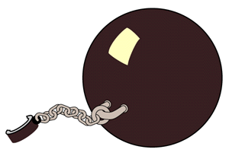
Strawberries and bananas don't cause cravings. You never feel guilty about eating too many cantaloupes. You never hear little voices in the back of your head saying “eat, eat, eat cantaloupe.” No, because natural foods balance the body and physical cravings are caused by biochemical imbalance. Street drugs, alcohol, caffeine, nicotine, salt, saturated fat, refined starch and refined sugars cause cravings because they imbalance the body's chemistry.
Addictive substances cause the body to become dependent on an unnatural substance for homeostatic balance. Removing it causes withdrawals. During withdrawal, the addict suffers through the painful readjustment as the body cries out for the missing substance. In a desperate attempt to maintain homeostasis (chemical balance), the body demands the very substance that caused the imbalance.
The body’s homeostatic balance is affected by diet. Consumption of massive amounts of sugar, salt, caffeine or fried foods drastically affects homeostatic balance. Natural hunger becomes distorted as the body craves the substances necessary for balance. The body reacts as it would to any addiction. Powerful cravings override the body’s natural needs.
Food allergies can also cause an addiction-like dependence due to homeostatic disturbance. Your favorite foods are usually the ones to which you are addicted. You usually feel better immediately after eating the food that you are addicted to, but shortly afterward the allergic reaction produces a feeling of irritability. It causes flatulence, nausea, depression or headaches. Milk, wheat and eggs are the most common allergic foods. Each contains large protein molecules with strong glue-like bonds. If the appropriate enzyme necessary for digestion is not available, these protein molecules enter the blood undigested. The immune system attacks these fragments as if they were invaders. Homeostasis has been interrupted and if these foods are continually eaten, the body needs them for homeostatic balance, causing an allergen-based food addiction.

The brain has 100 billion neurons and 100 trillion connectors for memory alone. Each brain cell is dependent on homeostatic balance to function properly. High doses of sugar, salt, fat and caffeine can cause imbalances in the brain’s normal chemistry. Eating natural foods allows the brain's chemistry to function normally. Natural foods assist homeostasis, supplying vitamins, minerals, soft fibers, cell salts and enzymes to assist the body in maintaining balance. In a balanced state, hunger is in relation to the body’s need for nutrition.
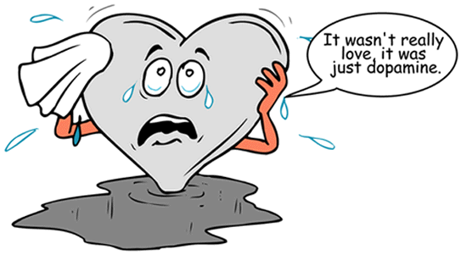
Eating processed food creates cravings for more processed foods. Eat fried foods, and you crave more. Eat cooked food, and you crave it. Eat sugar-filled food, and you crave it. The Hostess munchies are nothing more than disguised cravings for salt and fat. They promise satisfaction, but artificial pleasure never satisfies. It is a pleasure that gives by first taking. It steals valuable nutrition from your diet by feeding your body empty calories.

Addiction in the Brain
Scientists are discovering that psychological addiction has a common factor. All mood-altering drugs elevate levels of the neurotransmitter in the brain called dopamine. Tobacco, cocaine, heroin and caffeine elevate dopamine levels and cause a feeling of euphoria. Dopamine may be the master molecule of addiction.
Neurotransmitters, such as dopamine, control how the brain works and what we feel. When you feel pleasure from eating, falling in love, or receiving a compliment, it is dopamine that causes the feeling. Every experience that humans find enjoyable may be linked to dopamine whether it be listening to music, savoring chocolate, enjoying sex or shooting heroin.
Fifty neurotransmitters have been discovered to date. At least a half dozen are associated with addiction by causing a feeling of euphoria. Serotonin is another interesting neurotransmitter. It has a sedating effect. This neurotransmitter can be affected by rhythm such as stroking hair, slow, deep breathing, or a rocking motion. It is possible that the desire for the serotonin effect enforces repetitive habits such as nail biting, playing with hair or nose picking. There is a repetition and a rhythm to these habits. It may be an unhealthy attempt at trying to gain comfort from the serotonin effect. Starches have been known to have a calming effect on the brain due to increased levels of serotonin. We are using junk food, starch, drugs, and bad habits to adjust our feelings through stimulating our neurotransmitters.
The pleasure effect of neurotransmitters is designed by God to form healthy, natural dependencies. A wholesome pleasure motivates us to find good tasting food, comfortable shelter, and loving relationships. Dopamine and serotonin reinforce healthy actions and behaviors.
Dopamine has a powerful ability to form triggers. During pleasure, neurological pathways are being formed that will trigger a physical and emotional reaction to repeat that pleasure. We know it as an urge. We feel compelled. Our minds can become fixed on pleasure until we think of nothing else.
Intense pleasure forms the most powerful triggers. For this reason, sex, drugs and food create the most powerful urges. A syringe, rolling papers, an X-rated video, McDonalds, or anything that is associated with the pleasure becomes a trigger for these powerful urges. Compelled by an urge, we feel pulled toward pleasure like steel to a magnet. The emotions overdrive and our body quivers with adrenaline. An addict may shake and sweat with the anticipation of pleasure. A tennis player may also experience the same reaction before a championship. The body and mind are being prepared for action.
Urges are powerful at motivating us towards good or towards evil. We can feel the urge to pray, the urge to be kind, the urge to create or build, or we can feel the urge to destroy. Yet, even the most powerful urge cannot negate our responsibility. We can never blame an urge for the action we have formed, built and accepted. We have given it a power from the thoughts that we allowed it to form.

Stolen Rewards
Drugs hijack the natural reward system of humans. Smoking a joint feels like the relaxation similar to two hours in the gym. Heroin gives a pleasure similar to "runners high," the euphoric state experienced during long distance running. But, like all mood-altering drugs, the pleasure is stolen. It has not been gained honestly through effort, achievement or challenge.
Processed food hijacks the taste buds, stealing pleasure without giving nutrition. In nature, foods that taste good are good for us. Sweetness is an indicator of calories. Saltiness is an indicator of mineral content. A bittersweet taste, like lemon, is a sign of cleansing acids and vitamins. We like food with fats and oils because they supply calories and essential fatty acids. Natural oils and fats are high in calories and fat-soluble vitamins. Healthy food has a wholesome taste, a pleasure intended to reinforce healthy behavior.

A Security Blanket
Food can be used to medicate our feelings. Its pleasure gives a predictable lift. When we feel cranky, tired or lonely, food offers comfort, a comfort on which we can depend, a comfort that brings peace in an emotional storm. However, the reliance on food or any substance to feel better forms dependence.

The pleasure offered by mood-altering drugs and food can easily become a security blanket, insulating us from a harsh world. The pleasure becomes an emotional crutch that makes us weaker by leaning on it. Each time we use it, natural emotional responses deteriorate, and the addict becomes emotionally dependent on the pleasure to control mood.
When we are dependent on a chemical or food to feel good, our self-worth is eroded. We are no longer in control. We are dependent. An addict never feels good about needing a drug. There is a feeling of being powerless that destroys self-esteem.

Every time we are tired, upset or frustrated and use food to feel good, that behavior is being etched deeply into our neuropathways. Whether it be eating potato chips, gambling, sexual perversion, watching horror movies, or healthy activities like exercise or playing an instrument, the pleasure is creating triggers to repeat that behavior. Every time you enjoy a food that is unhealthy, use a mood-altering drug, engage in a perverse fantasy or enjoy being lazy, you are creating triggers. Triggers activate emotions, and become powerful urges to repeat that behavior.
After a lifetime's worth of indulgent triggers and twisted behaviors, we are out of control. Tidal waves crash upon the shore of our soul. There is no peace. The storm is relentless and the pain is endless. Hope is darkened. Only a glimmer remains. But it is enough to see.
Place a huge CAUTION sign over your pleasures. Choose your pleasures with great care. The pleasure of dopamine can move us forward towards a healthy, fulfilling life or endless indulgence. Through discipline, we can receive dopamine's pleasure from healthy activities and actions. We can feel good about doing the right thing while enjoying the benefits of a clear conscience and a healthy body.
Through discipline, you can control your neurotransmitters. Imagine being able to create nice, warm feelings … a “neurotransmitter high” without harsh drugs or side effects — just warm, dopamine-fuzzy feelings. Bet you'd be one happy person. In a few chapters you are about to discover how. We call it the Dopamine Diet Plan.
You can master our Cravings Defense System. When emotional and physical cravings rise up like a tag team punching from both sides you can hit back with a few uppercuts. Take no more beatings from Mr. Big©. Be the aggressor. Fight back. Chase those cravings away with a scowl. Flex some muscles. Show no mercy. Take no prisoners. This is war!

Chapter 4

Building Discipline


Welcome to the war zone. Decked out with your new florescent joggers, off you go to Mr. Muscle's Gym. Entering the world of fitness machines, you become increasingly conscious of the bulging belly stretching the elastic of your track pants. You discreetly suck it in as you walk over to the exercise bike, the only machine you recognize. It's been years. The seat seems so much smaller than you remember.
After a few moments of peddling, lungs gasp for air as the body screams, “What are you trying to do? Do you hate me?” Horror sets in as you realize how far your health has deteriorated. After only 20 minutes, you drive home to collapse on the sofa. Images from the gym haunt your mind: sculpted muscles and tanned, sleek bodies. “I could never look like that. This is me, so I might as well accept it.” Desperation calls for action. Staring wide-eyed at your vacuum cleaner, you consider Liposuction. But that's just too radical.
Most people connect discipline with pain. They consider the marathon runner training in the rain, and think that is insanity. It's no fun forcing yourself to do something you don't want to do. But if you are achieving an important goal, discipline becomes much easier. An athlete training for the Olympics does not have a grinding battle with willpower every day. Although there are battles, it becomes easier as the routine becomes a lifestyle.
Discipline is a mode of thought. It’s easy when you are doing it and difficult when you are not. But with patience, the right attitude, and keeping your mind on the goal, discipline becomes second nature. You don't have to force yourself. It just comes naturally. That is the way it should be. God wants us to become disciplined so He can bless us.

For God did not give us a spirit of timidity, but a spirit of power, of love and of self-discipline.
2 Timothy 1:7
It is easy to weaken discipline. Just spend years lying on the couch, watching TV, and eating junk food with no direction, goals or dreams. A lazy lifestyle weakens the discipline muscle to the point that getting out of bed takes effort. Even doing the dishes becomes work and searching for the TV converter is stressful.
Comfort is important. It gives happiness, right? I wish couch potatoes were the happiest people in the world. But, they are not. The couch is a prison cell, the TV a window to the outside world, a secure place that keeps out pain and rejection. The place is agony, for its walls scream you are powerless, hopeless, valueless with nothing to give. And so, couch potatoes live a miserable existence.
To gain discipline, you have to face pain. The more you face it, the more you gain confidence and determination. It is an exhilarating high to run five miles after you're conditioned to running. It hurts to start, but as your training progresses, there is a feeling of freedom and joy.

Facing Challenge
Challenge is exhilarating. We love competition for that reason. It challenges us to give our best.

We need challenge to grow. The greater the challenge, the greater the growth. That is why dreams are important; they bring us to the edge of challenge. The Bible does exactly that. It paints a picture of those who have overcome and are seated in heaven, surrounded by angels, ruling the universe from the golden, 1,500 mile-high New Jerusalem, and then challenges us to overcome. He who overcomes will inherit all this, and I will be his God and he will be my son. (Rev. 21:7) Challenge draws the best out of us, and God knows that.
In choosing your goals, choose goals that will challenge you beyond what you believe you are capable of achieving. Usually the things that we don't want to do are the best for us. Morning exercise is arduous, but it is a great way to start the day. When we face pain, our determination becomes stronger. Facing pain develops resolve and shakes off that overly sensitive-to-life feeling. Calisthenics, cycling, running, swimming and weight lifting strengthen discipline because they pit determination against pain.
Controlling food intake is a serious challenge. It is time to pit your determination against pain and face the ugly giant … the feeling of hunger.
Are you up for challenges that will cause growth? Are you up for challenges that will force you to give your best? If you are, it's time to make some decisions, durable decisions that won't weaken during the onslaught of temptation. You may lose a few battles, but with resolute decisions you will win the war because resolute decisions are powered by focused determination that screams, “I won't quit or back down.”

Decision Power
When you ate the donuts, you made a decision. They comforted you and led you down the path of sugarcoated, chocolate-dipped, cream-filled pleasures. When the alarm clock rang and you went back to sleep, you made a decision. When you ate another piece of pie, you made a decision. When you lazed on the couch instead of cutting the grass, you made a decision. Each decision was a path, the easy road where you decided to give into your cravings, urges and laziness.

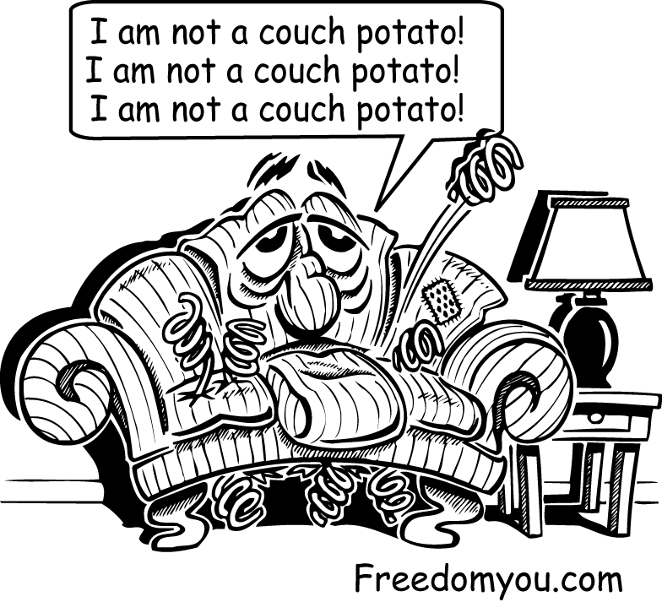
Most people make New Year's resolutions. They decide to quit smoking, start exercising and lose weight. Four days later, they're drowning in nicotine, pizza and reruns. Their resolution failed the test.
Where is the point where you have finally had enough and you make those resolute, I've-had-enough, never-go-back-again decisions? The ones that endure pain and stand the test of time. Those are the decisions that change our lives. We don't argue with those decisions because we know the answer is, NO! They are resolute. Gandhi stood resolute and unbending before threats of pain, and freed India. That is the power of an unmovable, unshakable, unbending, uncompromising decision. It is the power that shakes empires and inspires millions. A sword held by the hands of John the Baptist, Christ and the Apostles. Even death could not conquer them.
Life-changing decisions don't pop into our heads while watching TV. They are forged, like swords in the fires of our souls. A sword to cut away useless desires and temptations. To slice habits from our character with deadly precision. Its steel is heated with passion and conviction, then shaped, molded and tempered with wisdom. Its edge glimmers with light, sharpened so that nothing may withstand it. It is the power of decision, a sword in the hands of a conqueror for those willing to endure its sharpness.
You make hundreds of decisions each day. Most are decided by habit. Don't do that. Make your decisions, conscious of the path on which they are taking you. Choose decisions that challenge and cause growth. Make the decisions that force change for the better.
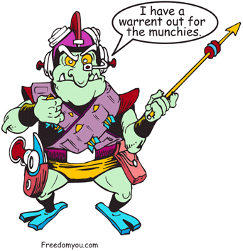
How badly do you want to be free from food addiction? Are you willing to face the ugly giant called hunger? Are you willing spend time on your knees before God to dig deep within the soul and pull out a determination that has the courage to meet every obstacle? You have the power to form life-changing decisions, but only if you are willing to face the edge that cuts dross from your life.

There are so many things that we believe we need. We hang on to hollow pleasures to soothe our empty soul. But those pleasures chain us. Freedom comes from letting go of those pleasures. Are you willing? Now, write out a list of your decisions.

Chapter 5

The Cravings

Defense System

The Munchies lurk in the shadows of your living room. It's an ambush mission. An innocent victim obliviously watches TV. They hit, full force during a potato chip commercial. You never saw it coming. Their main weapon is the urge. Not just a regular urge, but a focused craving that can be maneuvered at will towards a particular brand of potato chips.
Awareness is the first defense. In martial arts they teach you to deflect a punch rather than stop it. It takes less energy and uses the motion of the attacker against him. Deflection is the style of defense needed in battle against cravings. You cannot stop them by trying not to think of the munchies.
Like a boulder rolling down a mountain, cravings bounce and bang into other needs, stirring emotions and desires into an avalanche. A tiny craving has become a powerful urge that affects every fiber of our being. Allowing a craving to build anticipation can only lead to disaster. Deflection uses the energy of a craving to form positive thoughts. It is best done quickly before the emotions escalate.

Neurons
Your brain has adapted its neurons to your present lifestyle. For example, many people like to wake up slowly while reading the paper and drinking a coffee. Billions of neurological cells have become adapted to certain amounts of neurotransmitter stimulation, in certain sequence, at certain times. If a visiting friend interrupts that morning schedule, even if you are not conscious of it, there will be a feeling that something is not right. You may become irritable and edgy throughout the day. The brain has not received its normal doses of neurotransmitters in the normal sequence and rhythms, and they react with stress as though something were wrong.
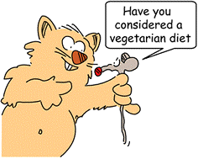
It has taken years to establish your present addiction to food. Your entire neurological processing is dependent on the pleasure of food for balance. Your neurotransmitters are expecting the next fix. Food is your escape, relief from worry, entertainment, and comfort, and is more intimate than your best friend. Removing food from its powerful position by cutting down food intake causes imbalance. You feel vulnerable and sensitive, similar to the effects of drug withdrawal. The symptoms are physical and emotional: anxiety, irritation, restlessness, headaches, stress and feeling out of balance. You are forcing your brain to change its neurological process, a change that sends shocks throughout the body.
As kids, we discovered an electric cow fence. No barbed wire and mesh for this farmer, just a thin orange wire two feet from the ground. We dared each other to touch it. Timidly, I reached out my hand. At first, there was nothing, then ZAP. I leaped back with a howl. After a few minutes, I calmed down. I decided that I could handle it, so I grabbed it again. Another ZAP but this time, I just let go. On the third time, I grabbed the wire and hung on, ZAP, ZAP, ZAP. I discovered that I could easily endure the shock if I just relaxed.
A small calf could have walked through that fence, but that small shock was enough to stop a 1000 lb. bull. Like that electric cattle fence, cravings keep us in place with small shocks. If we only held tight and ignored those shocks, we would realize how powerless they are.
Freedom is only a few shocks away. Let us leave the land of Burger Kings, Dairy Queens and burger shepherds wearing clown suits. It is a land of sickness, disease and death. If you listen in the quiet, you can hear The Shepherd's voice. Softly, He calls us onward. Green pastures and still waters await us.

Propaganda Defense
Twenty years of propaganda has an impact. We come to believe that cravings are good for us, a part of normal life. No point fighting them. It’s time to strip away the mask and see the raw ugliness hidden below. Cravings are powerful forces leading us to death and destruction.
To overcome cravings, you need to run an anti-brainwashing program to clean out the junk from childhood. Not only was your mind filled with reading, writing and arithmetic, but mind-washing thoughts as well, skillfully placed by the mentors of negativity. Like a computer virus, they infect your life by infecting your thinking. With cult-like force, they infiltrated the education system. Your teacher, your guidance counselor, or your school janitor may have been one of them. Even your parents may have fallen under the spell.
The only way to detect this hideous fraternity is by their common language. If you say, “it's a beautiful day,” they respond with, “what's good about it?” You mention singing birds. They complain about bird poop. You mention sunshine; they grimly suggest skin cancer. Every word carries the dark force of criticism, fear and complaint. Nothing is sacred. Nothing is cherished. Nothing has value.
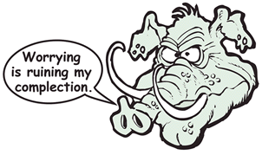
They have stubbornly made a decision to think the worst. You can't change that, but you can defend yourself against the onslaught of these malignant thoughts.
It is time to put the brakes on defeatist thinking and alter your mental dialogue. Evaluate what you are thinking. Are your thoughts inspiring, uplifting and encouraging or a stewing cauldron of worry, fear and doubt? Watch your thoughts. (No converter required.) Is your brain signal positive or negative? You will quickly realize how the negative thoughts have a far greater impact than the positive thoughts. If the thoughts you are thinking are negative, it's time to replace them with positive, uplifting, warm, fuzzy, nice thoughts.
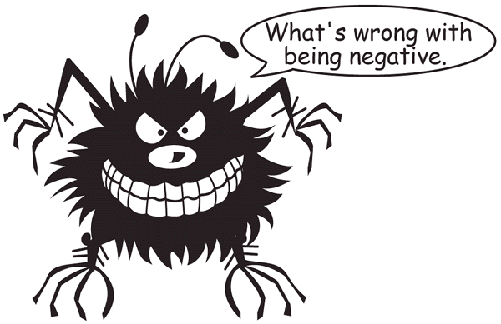
It's not easy. You can start out encouraging yourself and end up thinking weird and depressing thoughts. You may think a positive thought like “It's all going to work out.” And there is this depressing response saying, “no it's not, my life is falling apart.” It is here that the battle is fought. Stop fighting and negativity wins because you have decided to believe it. You have to fight with truth, repeating the uplifting thought until you believe.
The desire for comfort carries us on the path of least resistance. It is the easy way out. Who wants to swim upstream, when we can go with the flow? But the flow is going downhill to end in a stagnant cesspool of fear, worry and obsession. Going with the flow has a pay-off; we are doing something that is easy. And if we don't, we have to face our fear. It is easier to be consumed with worry than to do something constructive. You need to strive against the current of negative thinking, facing its power. It may feel like a raging current but the strength will come. Success is upstream, a place of freedom, joy and hope. It is the place we want to be.
Negative thoughts are hard to fight. They are like that floating pink elephant. The more we try not to think of them, the more they barge into our thinking. The solution is to deflect obsession to become encouraging thoughts. We have to re-channel the energy of obsessive, fear-ridden thoughts toward confidence-building thoughts.
Here are some craving defense thoughts.

“I can face this craving. I refuse to be controlled by food. I am staying on my diet. I hate junk food. It tastes like cardboard. It is addictive and steals my health. I feel weak, but I am making it. I am a fighter, not a quitter. I have control of what I eat. I can do all things through Christ Who strengthens me. I am filled with joy. I am at peace and relaxed. I have no worries. I have abundance in all things. All my needs are met in Christ. I am living in the peace of God. I am safe in His arms. I have abundant health. I recover quickly. I hardly ever get sick. God has done so much for me. I am truly blessed. This is going to be a glorious day!”

Imagine waking up to those thoughts. Imagine your attitude. Would your life be different? Wholeheartedly, I can say, yes, it will. Depression fades, insecurities evaporate, and worry transforms into challenge. Dreams become larger, as if built on new strength, because inside you know you can do it.
Your thoughts define your limits. Think defeat and you're defeated. Think you can't and you won't.
A small child at a circus was amazed to find such huge animals tied to a stake by a small rope tied around one foot. His father smiled and said, “when the elephant was young they placed a chain around its foot. No matter how hard the young elephant struggled, it could not break free. Eventually the elephant gave up trying and a rope replaced the chain.” Elephants and humans are the same; they are held in place by thin chords of attachment because they believe that they are unbreakable chains.
Believe you can. Perceive, believe then achieve. Become your own cheerleader. (No pompoms required.) Kindle the fire within. The Bible is a book of encouragement. A million angels are shouting you can do it. God Himself is cheering. You are a star in His universe.
Negative thinking gets negative results. If your present brain software isn't working, it's time to lap link your cerebral cortex to the most positive terminal in the universe, download a new program and reboot the system. Warning! Wear rubber boots for insulation; this is going to be one huge blast of positive voltage!

Chapter 6

The Brain Battlefield

You failed gladiator school. The military rejected you due to sofa disease. You were never cut out for war. Your jeans still have peace signs, but now you're in hand-to-hand combat with Mister Big ®, the Cookie Monster and Ronald McDonald.
Battling with desire hurts, especially, when you say ‘no’ to a pleasure that is moments away. As seconds tick by, you can feel your resolve eroding. The harder you fight, the more you suffer. Previous defeats make the battle even more painful. Emotions escalate, needs are not being met and past pain stirs up other neglected needs. You are moments away from blowing it. Your emotions are clanging like a pinball machine. This is the place where you win the battle.
Accept the intensity of your feelings. It is okay to feel this way. You can handle it. We feel driven to eat because we feel that we cannot endure the discomfort any longer, so we give in to get relief. But we can endure it, and much more. Try to let go and float through the pain. Find peace within you and hang on to it. Do not fight the desire. You don't have to act. Just float through the pain, accept the emotions, and remind yourself of what you really want.
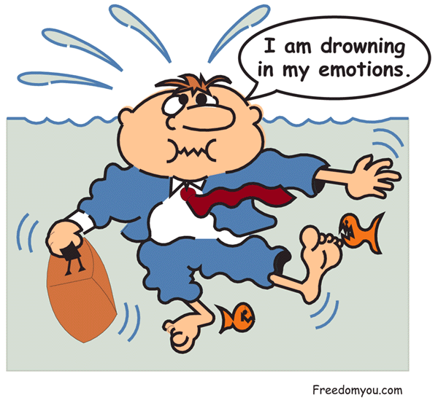
The battle is due to wavering between two decisions. If you were resolute, there would be no conflict. The battle is escalating because you are allowing your mind to rationalize as to why you can indulge. Part of you is uncomfortable because it knows the consequences of wavering in that decision. Goals will be lost. The fleshy part of us is using rationalization to get at the pleasure. The reasoning will be faulty. Challenge your thinking. Most of the time, the rationalization is along the line of I feel hurt and I need this to feel better. Challenge your thinking. Is this the best way to ease the pain? Is this really what you want? Make a decision. If your decision is to indulge then enjoy it, but remind yourself of the consequences of that action. And remember that doing something once is giving yourself permission to do it a thousand times. “Just this once” is a lie.
You do not have to go to a gym to develop discipline. You can flex the mental muscle while doing laundry. Every time you apply mental effort to relax, pray or encourage yourself, you are developing self-discipline. Even doing dishes can develop discipline by keeping your thoughts positive, staying at peace, praying and feeling good about your accomplishments. Not only do you get clean dishes, but also a clean thought life.
Write a list of all the positive things you can say to yourself to encourage yourself to eat healthy and then start thinking nothing but encouraging thoughts. After a while, it will become automatic. You will realize that most of your down times and frustration are due to negative thoughts. When you change your thoughts, you will change how you feel. It is just a matter of doing the work.
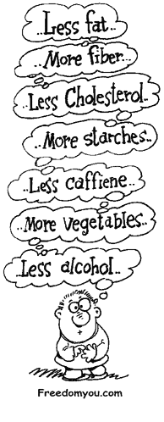
Remember that you have spent years as a negative thinker. This is not an overnight project; you need to add about a hundred positive thoughts to compensate for the twenty negative ones. It will take time, but you will see the benefits within hours. You will be more at peace, discipline will increase, and you will feel a sense of accomplishment. Best of all there will be an overall feeling of wellbeing that feels natural. There will be far fewer compulsions and urges, as you become more content. People will greatly enjoy your company because you are at ease with yourself and others. Investing in your brain has the greatest gain.

Chapter 7

Becoming Your Own Cheerleader

Here is a list of encouraging statements you can say to yourself. Once you get the idea, you will easily be able to make up your own.

Becoming Enthused

About Your Diet
“When I eat only fruit, I feel much healthier, and my mind is clearer. I really enjoy the taste. I like to live this way. My health is improving as my body is being cleansed.”

“I hate junk food. It tastes like cardboard. It is addictive and steals my health. “

“Fruit is delicious, full of natural fiber, minerals and vitamins. It is easy to prepare and filled with balanced nutrition that digests easily. I love eating fruit. It is good for me.”

“When I eat fruit, I feel really good. My mind is clear. I awaken feeling refreshed. My skin is healthier. My lungs and sinuses feel clearer and I have more energy.”

“When I eat mostly fruit, my discipline strengthens. “

Fighting Cravings
“I can face this craving.”

“I am staying on my diet.”

“I refuse to be controlled by food.”

“I am a fighter, not a quitter.”

“I will eat later when I can enjoy it.”

“This is a test of my willpower, and I am passing it.”

“I have control over what I eat.”

“If I eat it, I will feel terrible afterward.


If I pass the test I will feel good about it.”

“I have everything that I need to be content.”

“I can eat later. I will enjoy my food more if I eat when I am hungry.”

“I think that this is enough food. I am content with what I have eaten.”

“I have the power to stop obsessive thinking, worry or depression. I can do something positive to fight against it.”

“I do not enjoy eating when my stomach is upset.”

“The craving is stealing my self-respect, joy and peace. I will not give in to it.”

“I can face the pain of emptiness, loneliness and sadness because I know that joy will come.”

Facing a Challenge
“Most people quit. I will not quit. I am a fighter. I can do it.”

“This is easy. I am going to enjoy doing this.”

“This is nothing. I am up for the challenge.”

“I will succeed. It is just a matter of time.”

“I can do all things through Christ who strengthens me.”

“This problem is an opportunity to be creative.”

Reduce

Worry and Frustration
“God is in control of my life; this will work out.”
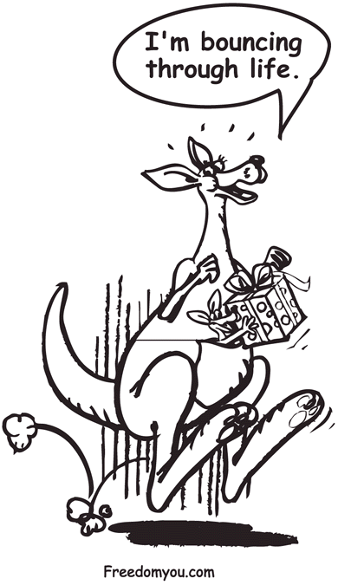
“I am living in the peace of God.”

“I can feel stillness in this chaos.”

“Christ keeps my life in perfect order.”

“I make the best out of the worst of situations.”

“I love a challenge.”

“I am safe in the arms of Jesus.”

“I let go and give my life to Christ.”

Being Happy
“Today, I celebrate God. I am full of joy.”

“I have a healthy attitude.”

“I am awestruck with the beauty of creation.”
“I choose to be happy right now.”

Think Health
“My memory is good.”

“I have abundant health.”

“I recover quickly.”

“I very seldom get sick.”


Warm your heart with the fire of enthusiasm. Take a full week to fill your mind full of positive thoughts and images. Refuse to let negative thoughts control your emotions. You have spent years thinking distorted, self-defeating thoughts and the result has been misery, frustration, obsession and feeling worthless. Encouraging thoughts make self-discipline easy. There are no more mental wars, just peace. Saturate your mind with noble thoughts and the world becomes new. You will see beauty in the smallest flower and find peace in a singing bird. You will feel joy in the tiniest of gifts because you know from where that gift came.

Chapter 8

God's Commercials

The TV generation is being raised on the pabulum of sitcoms, cartoons and game shows. It’s a generation of spoon-fed dreams and corrupt morality. There are a million images for impact. The target? It’s your wallet and imagination.
Watching TV is a full-time job.
Yet, God hungers for your attention.
Great achievements start with a vision. With time and effort, those visions sprout into reality. Dreams and visions give us direction. We head towards our dreams the way a plant seeks light. When we feel secure and comfortable in our minds with a dream, that is the path we will most likely take. Dreams make achievements reachable. Dreams remove our fear of sacrifice and build courage and desire to reach that goal. Visionaries become great leaders. For a person with a vision, accomplishment is the natural outcome. They believe it will happen, and success is just a matter of time and effort.
Imagination ties into the power of faith. Because we are created in God's image, we have the capacity to bring into being what we believe in the most, either for good or bad. Reflecting on my life, I realized that my thoughts and imagination preceded everything bad that had happened. I thought about it, imagined it, then it came into being. What I had believed was brought into being. My thinking preceded both the good and bad.

If you believe, you will receive whatever you ask for in prayer.
Matthew 21:22

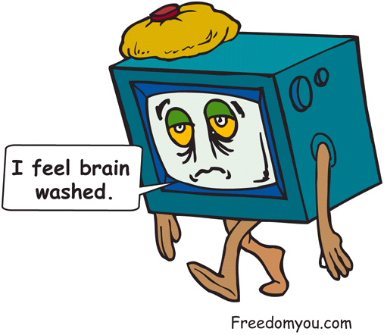
Worry about getting a spot on new clothing and sure enough, it appears. Visualize negative imagery and the faith principle will work towards making that imagery a reality. If you see yourself as an unhappy, fat, sick, out-of-shape failure that is unloved and rejected, then those factors will multiply. Imagine disaster and the worst usually happens.
Stop imagining yourself negatively. See yourself at your best: healthy, happy, composed, in control, full of joy and peace — then believe it. Remember God's commercial. You are a child of God whom He loves. He values you. You are important to Him. You are one of a kind. Imagine what He feels looking at you. A father cannot help but love his child.
Imagination is a gift, and we need to use it to:

- Encourage us to achieve
- Inspire noble sacrifice
- Stir us to challenge
- Give hope in suffering

Imagination fuels our desires. The pizza was cooking in your brain long before it arrived at the door. If it is not pizza, we are imagining disaster, problems and creating horrible pictures to fuel our worry.
Fight against negative imagery by using your imagination constructively. Visualization is easy; just have a daydream of yourself enjoying a great day with everything just perfect. If you are to be playing a sport, see yourself giving it everything you have, playing the best game you have ever played.
My friend and I kept losing on the badminton court. Our opponents were really good, and we were just learning. But, we had just learned how to visualize, and this was a chance to try it out. We went in there with the attitude; we are going to return every shot. We are going to play the best we have ever played. I envisioned us winning, and it happened. We beat them with a score of 21 to 12 and 21 to 8. Twice we beat them. We were stunned as much as our opponents were. We never thought that we could win, never mind demolish them.
The imagination had stirred us to play harder. It had brought the best out of us. And that is how we want to live, at our best. Our imagination is a creative force.
God spoke a Word and the universe came into being. We have been given a minute aspect of that same power.

Relaxation
Are you ready for a vacation? Come on a journey to peaceful places and tranquil waters. A place to ease your tension, a place which is stress-free and worry-free. No ticket required no terminal lineups, no airsickness. Buckle up for destination paradise!
Your imagination works best when you are relaxed. To prepare yourself, get into a comfortable position in a reclining chair or lying down. Read the exercise, then try it.

Destination Paradise
Take five deep breaths holding each for three seconds, then releasing slowly while relaxing the body. As you breathe out slowly, think the word peace.

You're going to vacation in 1,500 mile-high city of God. In the center is a garden paradise, lush with Amazon flowers, trees and colorful, tropical birds. A shallow stream meanders through color-covered banks. A rubber raft is on the shore and you are going for a ride. Get in the raft. Imagine yourself drifting, the hot sun bathing you in light as you watch the birds and dragonflies. A gentle breeze blows through the treetops. It’s a perfect day, a perfect temperature. And you have nothing to do but float downstream in paradise. Breathe deeply, releasing slowly. Really let yourself go. Let go and trust in God. Let the tension go. Let the worry go. Let the fear go. Be at peace because you are safe. If you start becoming tense, refocus on breathing deeply and slowly, saying peace with each exhalation.

Letting Go
Once you are comfortable, become aware of your breathing. Breathe deeply like you are drinking in oxygen to a thirsty body. Take a deep breath and let it go slowly. When you breathe out, imagine you are exhaling all the worry, fear, pain and doubt from your body. Feel it leaving. As you breathe in, the life-giving oxygen is filling every cell with life. You are becoming more at peace with each breath. You can feel the presence of God with you, comforting you. You are safe. See the problems in your life. Consider them for only a second, then give them all to God. See Jesus taking them and putting them in a bag. He takes them and says, “I will take care of this for you.” And then comes a peace that transcends all chocolate chip cookies.
If you feel uncomfortable, reassure yourself that it is okay to put your problems in the bag.

Peace
Get into a relaxed state by breathing in until the lungs are full, holding for two seconds, then breathing out slowly, while thinking peace. You are ready for battle. To the food that you are resolved to give up, you will boldly shout “NO.” The foods, to which you are not ready to give up, you will weakly say “NO.” Consider why you are not willing to give them up. Write all the reasons why you do not want to eat that food so your resolve is strengthened, then try the exercise again. If you spend time doing this, and you face a temptation, your response to that food will be an immediate “NO.”

Body Relaxation
Scan your body from head to foot. Are there any areas of tension? If so, take a few deep breaths, hold, then release slowly, saying “relax” to these parts. Are your neck muscles or jaw tense? Focus on relaxing these muscles. Do you have tightness in the shoulders? How are your emotions? Are you fighting worry or anxiety? Is there a feeling of hurt? To these uncomfortable emotions, say “peace” and let go. Create a feeling of contented relaxation. Do not wrestle with your thoughts. Watch how they enter your thinking and gather momentum and feelings. Just keep letting go, saying “peace” to yourself and relaxing the muscles.

Let Go and Enjoy
Uptight people lead miserable lives. We take ourselves too seriously. We take the war with food too seriously. When we stop being kids, we stop having fun. Even the hardest things like dieting can be fun. We can win by loosening up.
Compulsive eaters eat in a tense manner. When we eat anxiously, we are eating in a dazed state, similar to biting the nails and not truly conscious of what we are doing. The enjoyment is greatly reduced and we keep eating to feel satisfied. But, eating in a dazed state never satisfies. Your mouth is chewing, but your mind is worrying. You didn't enjoy the food; you ate a plate of problems. Relaxation breaks that pattern. Relax before eating, during eating, at the refrigerator door or whenever you feel tension or are eating compulsively. A few slow, deep breaths reduce tension and anxiety. Slowing down makes food more enjoyable and helps you to eat less. Become relaxed and be at peace several times per day. The Bible calls peace a guard, because peace protects us from distorted, compulsive, obsessive thinking. Wouldn't you love to be at peace?

And the peace of God, which transcends all understanding, will guard your hearts and your minds in Christ Jesus.
Philippians 4:4

Imagination
Enter a relaxed state through taking deep breaths, holding for two seconds, and releasing slowly as you say the word peace. Here are some effective mental exercises that will build enthusiasm to eat correctly, and stay positive.

- Imagine yourself living perfectly on your desired diet. See the joy on your face and imagine how good your body feels.

- Imagine you going through the day and eating perfectly, being happy and eating healthy foods.

- When you get home from work, imagine yourself going into the house happy and content and eating the right foods.

- If you are going to a restaurant with some friends, imagine yourself ordering a small portion of something nutritious and being content with that.

- Whatever task you are about to do, imagine it going easy. Imagine it being fun and enjoyable completing the task.

- Before you go to bed, imagine yourself having good, relaxing dreams and a peaceful sleep.

- If you are entering a conflict, imagine it all working out and the conflict being resolved.

- If you are learning an instrument or playing a sport, see yourself doing it perfectly.

- Before you go to the gym, imagine you are going to have an excellent workout and feel good about it.

Spiritual Snap Shots.
- See yourself happy, full of peace, love and joy, walking in the freedom of Christ.

- See yourself gaining in strength, courage, honesty, determination and persistence.

- See yourself before the throne of God.

- See yourself living a disciplined life, radiant with life, love and success.

- See yourself with no needs, content and wanting nothing.


- See yourself being tempted and winning.

Chapter 9

Yuck Power

Imagine a dead animal at the side of the road crawling with thousands of white maggots. The image of maggot-ridden road kill will effectively stop you from eating a hamburger or anything else you were thinking of munching on.
Yuck power can shock you back to reality. Overeating greasy, salty, chemical-laden food is not normal. TV advertisers have associated toxic food with fun and enjoyment. We are told that we deserve it. Meanwhile, the followers of this golden message are riddled with disease from the effect of this modern-day diet. Even in the face of illness, we still associate salt, sugar and fat-filled foods with a pleasure that we deserve.
As a cure for emptiness, the pleasure of food can become drug-like in how it affects our thinking. It becomes distorted. We become obsessed with pleasure. Like an addict, we become fixed on that pleasure and forget the harmful effects. Pleasure becomes our god — a god who trades moments of comfort for control of our lives. We dance to its urges like puppets on a string. It’s a dance of death. Pimples, embarrassing gas, obesity, bloating and disease are signs on the road to oblivion. It is time to turn around.

Stuck on Replay
The closer we are to receiving pleasure, the more we think of it. We remember the pleasure and we want it again. We remember the enjoyment, and forget the negative effects.
When we want pleasure, we replay the best part of the experience. We build anticipation by remembering the pleasure over and over again, like listening to a favorite song without playing the rest of the tape. We rarely play the tape to the end. Who wants to see all the images of depression, sickness, obesity, guilt and all the other fun stuff that goes with indulgence?
When a drug addict thinks about a drug, he remembers the rush. Reliving the experience of pleasure builds anticipation. As he focuses on the rush, the more the anticipation increases the desire for pleasure. He ignores the loss of money and health, the pain of withdrawals, jail and all the negative consequences associated with drugs. Drug addicts and alcoholics have pleasure-centered thinking. If they forced themselves to look at the entire picture, they would not be using drugs.
We do the same with food. We become fixed on the pleasure. Instead, we need to force ourselves to look at the consequences of overindulging: greasy skin, pimples, cavities, rolls of ugly fat, and disease-rotted flesh from a body overloaded with food additives. Go ahead, have another piece of cake.

What Do You Really Want
Do you really want to eat junk food? An honest answer is ‘no’. But you have come to believe that 30 seconds of taste is really what you want. But that is a lie. Infatuation is to love an image. Addiction is to love an illusion. It is an illusion to think that a chocolate bar will satisfy you when, immediately afterward, you will feel unsatisfied.
Get rid of the illusion. It is 30 seconds of high-calorie, health-destroying taste pleasure that you don't need. If you think of the reasons why you hate chocolate bars, you will not eat them.
We try to fight the battle of compulsive eating during the moments just before eating, but that is the least effective time to fight. You need to fight the battle when you are walking, sitting or waiting in line. Ask yourself, what do you really want? Do you really want to be a chocolate eater? You need to go over the reasons for quitting chocolate again and again until it enters the subconscious. If you do this mental work, the next time you are offered a chocolate bar you will say “NO” without thinking. If you ask yourself why you said no, you would answer, “I just don't like them.”

Revulsion Power
Remember the restaurant vegetable soup with the 4-inch long hair hanging off it? And what about the pizza? The black thing with legs didn't taste like an anchovy! Although bugs are naturally crunchy and high in protein, finding one in your food takes all the fun out of eating.
The interesting thing about the effect of revulsion is that it can be created and amplified to the point of nausea at will. Try it a few times. The first time you may have to think intently of the road kill or a hair in your soup, but after a few tries you will be able to create the effect of nausea at will.
The nausea effect is a powerful tool to help you stop overeating. It will shut off the pleasure tape and give you time to refocus on what you really want. It will cause you to jump out of the obsession cycle and give you a chance to look at the importance of your goals.
You can use the revulsion technique to stop overeating. Cultivate the feeling of revulsion and say to yourself “I don't feel like having any more food.” Leave the food area and get moving. No battle of will, no fighting obsession, just one second of feeling nausea and off you go. Why wrestle with your thoughts when a simple technique will work? Feeling good about being disciplined will far outweigh the few seconds of feeling bad.
Here is an example of using revulsion. The church had decided to have donuts and coffee after the service. Dozens of donuts of every type were being laid out. During the service, I started thinking of the chocolate-covered ones with gooey cream filling. Halfway through the service, I wanted a donut. I can't remember the sermon, but I sure remembered which tray the chocolate donuts were on. It became a battle of will. Emotions were escalating. Now I really wanted a donut. “Hey, I'll try the revulsion thing. I'll just do it and hope it works.
Donuts . . . toxic oil, white flour, salt, sugar, no nutrition; it’s probably been in a five-gallon bucket for five months before they made it. Donuts give me headaches and make me feel awful.” Then I created a feeling of revulsion and thought of the donut. I did it twice, then listened to the sermon. I never ate one donut. I was amazed that it was so easy.
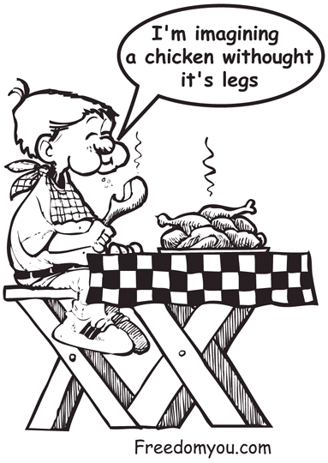
Creating revulsion is simple. After a while, you will be able to create the feeling of revulsion quickly and easily. Practice using it. Open the refrigerator door, create revulsion then do something else. Use it when you are battling the munchies or getting past the bakery section of the grocery store. Use it several times a day, for two or three days and it will become a powerful tool in controlling compulsive eating.
Revulsion can work on bad habits. Repeat the habit, then create the revulsion. It works on obsessive love. Create the repulsion as strong as possible, then visualize the person you are obsessed with. It works on depression caused by loss. For example, you were to buy an amazing house but the deal fell through. You can become depressed for days because you lost something special to you or erase the desire from your mind by thinking about the house, ridden with termites, with a leaky roof caving in. The feeling of loss will evaporate as you visualize the dilapidated house while creating a feeling of revulsion and thinking of all the negatives about the house. Becoming thankful that you didn't buy it is to put the loss behind you.

When to Use Repulsion
- When you are not hungry and you are thinking about food.
- When you are overeating.
- While visualizing the foods you are trying to quit.
- To help deal with loss.

Exceptionally

Revolting Thoughts:
Donuts: Fat, salt, white flour and sugar. The hole is the most nutritious part.
French fries: Sponges dripping with 14-day-old grease.
Cereal: Styrofoam with artificial flavor.
Margarine: Spreadable plastic.
White bread: Great for colon cancer.
Bacon: Pig fat to human fat.
Coke: Teeth-dissolving and stomach-dissolving fluid.
Milk: A glass of animal fat sucked from a cow udder. (50% of its calories are fat.)

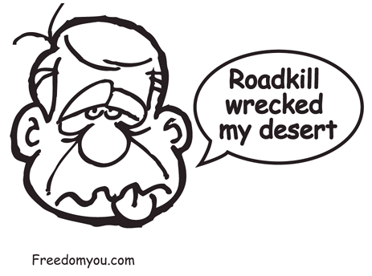
Use revulsion to reaffirm your desire to eat healthier. Imagine yourself in the chair watching TV and gorging on junk food. See yourself getting fatter and fatter. You are getting sick. A tumor is developing. Your arteries are clogging with fat and sticky cholesterol. You have diabetes from eating too much sugar. Your colon has a tumor bulging from it, and you need a colostomy. Imagine a fat, wrinkled, sick person on his deathbed. It is you. After that, be thankful that you have made the decision to eat nutritiously. Feel good about what you have accomplished. Imagine yourself eating healthy and feeling great.

Chapter 10

The Dopamine

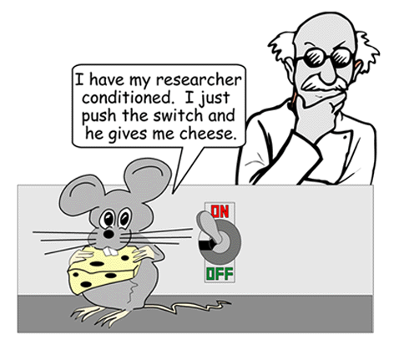
Diet Plan

The Apostle Paul was filled with contentment, peace, love and joy. He was a slave to righteousness. He was addicted to the joy of doing the right things and serving God with all his heart. Even in jail, he sang songs of joy. God intended for us to feel good about doing what is right. That's why He made dopamine.
The pleasure of dopamine has the power to form both healthy and unhealthy behaviors. The dopamine diet plan will help you to become addicted to eating healthy. You will form good behaviors by making what is good for you as enjoyable as possible. Eating spinach because it is healthy when you hate it will not work. When you make healthy eating an enjoyable, taste-filled experience, you will want to do it again and again. Neurons and synapses will form new patterns. Red lights will trigger the desire for juicy watermelon. Hunger will shout, cantaloupes! The cravings for unhealthy foods will fade like a bad dream. No more cravings for fat, salt, sugar and chemicals, the body's biochemistry is rebalanced to a clean bloodstream filled with vitamins, minerals, enzymes and natural fruit sugars.

Creating Healthy Triggers
We associate events and images with food. These associations become triggers for that food. Hot summer days can trigger the urge for ice cream. Campfires can trigger the urge for marshmallows. Baseball games trigger urges for hot dogs. Seeing a donut store can trigger an urge for coffee. The golden arches of McDonalds can trigger an urge for a hamburger. Food triggers are worth millions. A marketer's dream: consumers like rats in a cage, pushing levers for another fix, programmed by pleasure and willing to pay cash.
Create triggers for the foods you want to eat. Here is how to do it. Imagine a bright orange cantaloupe, glistening with beta-carotene and enzymes, ready to nourish every cell, as good for you as it is low in calories. Imagine enjoying a plate of chilled cantaloupe slices, sensing peace and comfort coming over your body. See yourself relishing every bite and being joyful of God's blessing. See your body being flooded with nutrients and making you feel so good, so alive. Feel the warmest, most comforting feeling and connect it with the taste of cantaloupe. See yourself after eating a plate of chilled cantaloupe slices. Savor the feeling of contentment. Now when you eat a cantaloupe, enjoy it to the fullest, relishing every moment. If you do, dopamine will help you to form healthy triggers.
Be careful, some people have overused this trigger-creating technique and developed a serious cantaloupe addiction. We are thankful for the 12-step program, Cantaloupe Eaters Anonymous.

Contentment
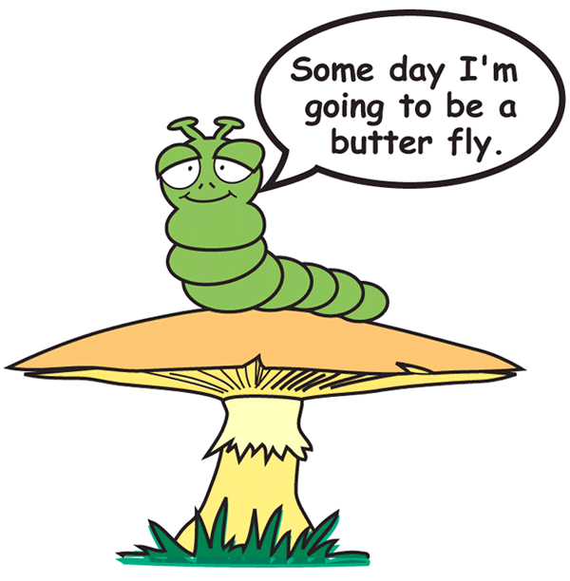
Do you feel good about what you have accomplished? If you are like most of us, the flaws seem gigantic and the accomplishments seem tiny. After a success we think, That's no big deal, anyone could have done it. We never stop to allow ourselves to feel good about our accomplishments. Even in success, we choose to look at the flaws and beat ourselves up because we are not meeting some impossible standard. But self-criticism destroys motivation. Self-criticism destroys the desire to achieve. We feel hurt and become resentful toward ourselves.
When we don't feel good about what we are doing, we get discouraged and frustrated. On the other hand, feeling good about what we are doing gets us enthused, excited and motivated.
Feel good about the tiniest of accomplishments. Take the time to enjoy the feeling of completing a task, sticking to a diet by making a healthy meal, exercising or just waking up early. Let the emotion of accomplishment build and be thankful to God. Sense the peace. Sense the feeling of well being. Allow yourself to feel good about doing the right thing. Do not tear down your accomplishments or compare yourself to others. Take the time in each day to consider your accomplishments. Instead of looking at the flaws, dwell on the feeling of satisfaction. You deserve to feel really good. You have done well.
Very few people care about your accomplishments, but God does. God cares about everything you do. He wants you to be healthy, happy and full of joy. He wants you to feel good about yourself and your accomplishments. Feeling good about what you have done is the reward for your hard work, so enjoy it. It is not being selfish.

Each one should test their own actions. Then he can take pride in himself, without comparing himself to somebody else.
Galatians 6:4

Being Filled with

Joy and Peace
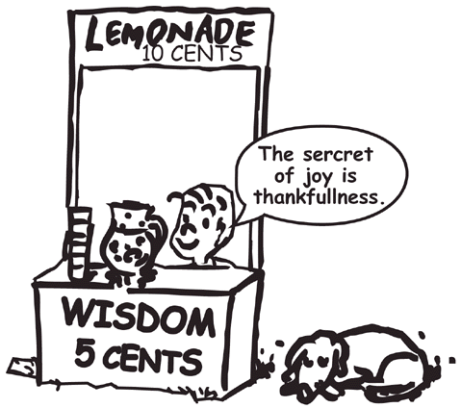
Even in the midst of misery and unhappiness you can create the emotion of joy. You can choose to be happy. Make a decision to enjoy the moment. Stop reading for a moment and create the emotion of joy. Loosen up, wave your hands around, dance, smile, shout, “yeah!” Sing a happy song. “I've got the joy, joy, joy, joy down in my heart.” See yourself dancing, laughing swirling in the sun, you're so happy. Let the emotion build within you, happiness and thankfulness bursting from your heart. Become flooded with a warm feeling of peace. Take a deep breath. As you breathe out, all the tension is going. You feel nothing but peace and joy.

Always be full of joy in the Lord. I say it again--rejoice!
Philippians 4:4 (NLT)

Being Content with

Eating Less
Here's a way to stop overeating. At the point where you feel that you should stop eating, stop and feel content. Become aware of how full you are. Let the feeling of contentment build while being aware of feeling full. Ask yourself, do you really want to eat more? Now start to clean up or brush your teeth.
If you are still struggling with wanting to eat more, create the feeling of revulsion to eating more, then return to creating the feeling of contentment. It is rare that you will have to do this more than once. It is easy, simple and fast. Once the compulsive desire is gone, get active to keep your mind busy.

Being at Peace
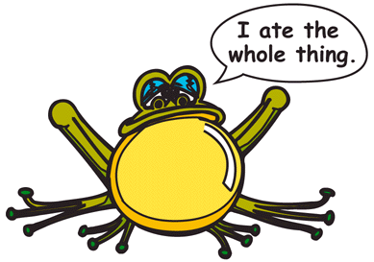
Worry builds fear by imagining the worst. Yet worry changes nothing. It destroys our peace and makes us feel powerless. Worriers have the most problems and the hardest time solving them. Problem solvers refuse to worry; they get down to what they can do, and then do it. Everything seems to work out for them. They have tolerance, motivation and are generally happy.
If you examine your state of mind during a refrigerator hunt, you will realize that fear and worry are often the motivation to eat. We eat to feel good about life. Worry and fear make us feel out of control, and eating gives us a sense of being in control. Eating becomes an escape from the dark world of our thoughts. However, using food as an escape abuses our body and leaves us feeling powerless.
Refuse to worry. Get the problem down on paper. Examine the worst possible situation and what you can do about it. Once you have made your decision, stop worrying and start thinking healthy, encouraging thoughts. If the desire to worry surfaces, you can make a stand against it because you have made a decision.

The Flavor of Hunger
Did you notice that the first four cookies at the top of the package taste really good, but the ones at the bottom, 24 cookies later, are sickening? Taste is deadened by overeating and is stimulated by hunger. The hungrier you are the better food tastes. The more stuffed you become, the worse food tastes.
Most people quit on a diet program because they feel deprived. You need to enjoy eating healthily. Hunger greatly increases enjoyment. Take a chance. Face the ugly giant of hunger. You will be well rewarded. When the flavor and enjoyment of food is enhanced by hunger, your brain is getting the dopamine high and forming attachments to healthy foods.

Dopamine Reduction Guide
Many who follow this program have felt guilty because of the intense pleasure and health that they are experiencing. They felt that it wasn't fair to be living in such an exuberant state while the rest of the world suffered. If you want to decrease the amount of pleasure you are receiving from food, we have laid out a 12-step process to return you safely to the normal world of eating. It is designed to reduce dopamine levels to almost nonexistence.

- Eat fast so you do not get to taste the food. Chew no more than three times.

- Do not prepare delicious meals. Try to eat standing up eating hand-to-mouth out of the fridge or cupboard.
- Eat stressed out. Try eating while driving a car. If you are too relaxed, your stomach will be able to secrete digestive juices. Eat while worrying about a problem. If you do not have any problems, ask your co-workers if they have any problems for you to worry about.

- Eat while distracted. Open bills, watch TV, do homework. Mentally, be somewhere else. If you have no distractions, just stare blankly into space.

- Eat while feeling guilty about eating too much. Remind yourself that you are a fat failure. Try to stare at your excess fat as you eat and imagine it growing. Guilt is great at reducing motivation.

- Eat when you are not hungry so the taste buds are dulled.

- Eat super-salty, sugar-filled foods to numb your taste buds so the natural, delicate flavors of fruits and vegetables will be powerless to stimulate any taste reaction.

- Increase spoon and fork speed to feed the mouth as fast as possible. This greatly reduces enjoyment. Some people find using their hands is the quickest way.

If you can eat this way, you will receive no satisfaction from eating. There are two small problems associated with our Dopamine Reduction Guide: the problems with dieting and its poor health return. The end result is an obese, diseased, unmotivated individual. The good part is that you have lots of company.
Being miserable and unhealthy is not what God intended. When God created Adam, he wasn't just practicing. The human body is the most amazing creation on earth. Nothing on earth can compare in its complexity. Yet, we treat our bodies like used cars. After years of abuse, it finally breaks down. God intended us to experience health, joy and peace. He wants our heart to burst with thankfulness, not high blood pressure. He wants us to live in freedom. He wants us to enjoy all the good things He has created. Wholesome pleasure is His gift to us.

Chapter 11

Facing Failure
The hardest person to forgive is self.

When Edison was criticized for his many failures at making a light bulb, he replied that he had found thousands of ways on how not to make a light bulb. It wasn't the one success that created the light bulb, but the thousands of failures it took to discover what didn't work. Every success is achieved by learning from failure.
You will fail. It is part of life. It is inevitable. Are you ready to face failure? Ready to face it not once, but several times? Are you ready to pick yourself up and go on with the battle? Most don't; they give up when they are at the closest point to success. But everything worthwhile takes time, investment and facing failure. Nothing worth gaining is gained without facing failure. Failure is a doorway. You need to be ready to go through it.
Failure is devastating if you have low self-worth. Parental criticism drove home demeaning messages: “you idiot, you blew it again.” Feeling like a failure, we engage in self-flagellation, beating ourselves up and making endless apologies. We become focused on not failing instead of achieving.
Fear of failure is a terrible motivator. Instead, it will cause failure. When we do fail, it proves to us that we are a failure and we believe it even more. But you are not a failure. Every human makes mistakes. Why should you be any different? Making mistakes proves that you're not perfect. We learn by our mistakes. They are a part of life.

Blasted by Guilt
Guilt is anger directed inward, like a shotgun blasting pellets of blame at every part of our character. It screams, “you're always blowing it.” It reminds you of all your other failures. You beat yourself up because you failed to meet some unrealistic expectation of yourself in a desperate attempt to regain control.
On the other hand, remorse or regret is good. It is good to feel badly about what we have done, see it as wrong, and want to change. Guilt ruins self-worth, but regret leads to change and growth. Guilt reinforces your belief that you are a "bad" person. Regret focuses on the behavior.
Guilt has a powerful effect on our thinking and emotions. When we feel guilty, we become sensitive and defensive. We close off to stop being hurt more. But although we have withdrawn, we have not changed. So guilt is really a cover-up because we never get to the point of feeling bad about what we did and taking responsibility. Guilt allows us to stay the same.
Regret works. Regret a bad choice. See it as a mistake. Become intent never to make that mistake again. You are not a failure because you made a mistake. You have made many good choices in your life. This wasn't one of them. Feel bad for a few minutes because of the benefits you lost. Grieve the loss quickly, refocus on your goals then move on. Getting enthused about your goals is infinitely more effective than beating yourself up with guilt. The past is the past, but our future is bright in Christ.

Brothers, I do not consider myself yet to have taken hold of it. But one thing I do: Forgetting what is behind and straining towards what is ahead.
Philippians 3:13

Wrong Choice
If you were on a diet and you ate a banana split, you made a decision. You thought about it, weighed the good and the bad, then chose to eat ice cream. Your desire for fudge syrup, whipped cream and pineapple topping was stronger than your desire to stay on a diet, so you made a decision.
After the decision, you instantly blasted yourself with “I shouldn't have done that.” If water flows down a predictable course, why should it flow down another? If you have a pattern of blowing your diet by eating ice cream, that pattern will continue until you change it, so how can you say you should not have eaten the ice cream? Your predictable behavior is to eat ice cream.
If you choose to eat ice cream, enjoy it. Make the best of the decisions you make. It wasn't the best decision, but you don't have to be perfect or make perfect decisions. Every decision requires you to weigh the good against the bad; otherwise, it would not be a decision
Blowing a diet by eating ice cream does not make you a failure. Who said that you shouldn't fail? Was it your parents? Society? Your peers? How can they expect you to meet a standard that they themselves can't keep? We all fail as humans; it is a part of life. When you are disciplining yourself, you will fail. And that is acceptable. It is OK to fail.
Guilt and the feeling of failure focus on the loss. We need to be focused on the challenge. No one would be reading this book if it were easy to stay on a diet program. So let's get realistic. You are not a failure. You made poor choices. Although you may know that, the feeling of failure is inevitable and you need to be ready to face it with courage.

No Good “Should”
Get rid of the word should. Should looks back. There could be a million things that we should have done, but we can't linger in the past; we are moving on to the future where we make the best of what we have and go on.

Instead of saying I shouldn't have
eaten that, say:
- “It would have been healthier if I had not eaten the __________.”
- “The best choice was not to eat the __________.”
- “The most disciplined choice would have been not to eat the __________.”
- “I would have felt better if I had not eaten the __________.”

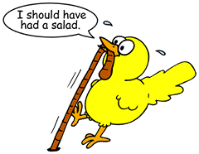
"Should" statements punish. Punishment causes resentment. Positive statements focus on the reward. Rewards motivate us.

When You Fail, Challenge
Your Thoughts of Worthlessness.

- “As long as I have something to contribute, I am not worthless.”
- “If the Creator of the Universe wants to be my friend, I am eminently worthwhile.”

Preparing for Failure
Expect your resolve to be challenged by emotional ups and downs. Temptation, getting depressed, becoming frustrated or disinterested can knock you off the path. If you are prepared in advance for the fight, you will be able to get back on the path as quickly as possible.
Prepare for failure by learning visualization skills, self-encouragement, creative relaxation, avoiding ‘should’ statements, making resolute decisions and reaffirming your commitments. With these skills you will escape the failure cycle. When you do, life will be a lot more fun. The little things won't bother you so much. You will take the ups and downs of life in stride. You may stumble, but you won't fall.

Overcoming the

Failure Effect
So you blew it. If you accomplish only a few of these steps, you will start to feel better. Discouragement due to failure is hard to fight; you will want to give up. So just try as best you can. If you can get started, your emotions will come in line and it will get easier. You will win over donuts, joints, cigarettes, beer, burgers and coffee. It is a matter of using the skills. Make it a brain workout. Get focused, get determined, pump your lungs with oxygen, and say it with determination. Do five sets of “I am not a failure.” Do six sets of “I don't have to be perfect. I can make mistakes.” Do 12 reps of “I have nothing to prove to this world.” Put energy behind the message; it has to get all the way to the heart.
Here are steps to break you from the habit of feeling like a failure.

Put the emphasis on what you have accomplished. “I have done really well so far on my diet. I am becoming better disciplined. This is just a minor setback. I can overcome this.” Let it build as a feeling. This is the hardest part because guilt causes tunnel vision.

Get rid of guilt. “I can make mistakes. I don't have to be perfect.” This only proves that you are human.

See the failure as a bad decision. “It would have been better if I had not____________.” Regret blowing your diet. Feel bad about the decision. Let the feeling build. This is not guilt; this is the desire to change. See what you have lost by choosing to indulge. Let your sadness build your desire to get back on track.

Get angry. You are not going to be pushed around. This is it. You've had enough. No more Mr. Nice Guy. Get storming mad at what tempted you.

Visualize the two pictures in your mind: you are blowing it and feeling bad. Let it build as a feeling of regret. Then visualize you being successful and feeling good about it. Visualize what you wished you had done. Visualize you are doing the right thing and feeling good about it. Let it build as a desire.

Think of all the reasons why you do not want to eat. For example: Donuts are full of fat, white flour, salt, sugar and food additives. They just taste good and that is it. Let it build as a feeling of determination that you will not eat them any more

Why do you want to eat nutritiously? Remind yourself of those reasons. It is your heart's desire to eat healthy, so you can enjoy a vibrant life. Let it build as a feeling of desire.

You are forgiven by God. You have forgiven yourself. Refuse to be down. It is in the past. Time to get on with life. Shake yourself up. Create good emotions: “I feel joy. I feel peace. I feel love.” You are a fighter, not a quitter.

Rebuild Determination
- “I can make mistakes. I don't have to be perfect.”

- “I will fail. It is inevitable. I need to take it in stride and get back on track. Each success will have several failures.”

- “I am in control. Even if I slip in my commitment, it was a decision I made. I may feel out of control and everything is hopeless, but it is not true. I am in control.”

- “So what, this is not the end of the world. It is a minor thing. Everyone makes mistakes. I don't always fail. I will decide what I am going to do about this. “

- “I am not a failure. I am a disciplined person who made a wrong choice. I have achieved much through discipline in my life.”

- “I will learn from this mistake. I will study how I feel and write out what works and fails to help. I need to be prepared for the feeling of failure because it is inevitable. It is not the number of times I fall but the number of times I get up.”

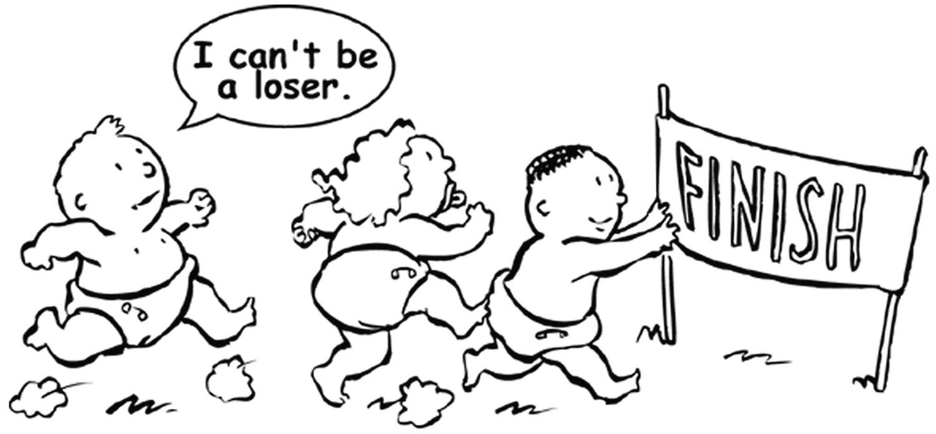
- “It is OK to feel hurt about making a mistake. This will pass. I will do something encouraging to get myself back to thinking positive, then I will feel better.”

- “My heart's desire is to eat healthy. It is worth fighting for.”

- Visualize yourself coming out of the depression and being happy getting back on track.

- Review a list of the things at which you have been successful.

Spiritual Encouragement

- “God loves me. All I have to do is try.”

- “Lord, I feel helpless and powerless, please help.”

- “I let go of my failure and give it to You, Lord.”

- “I have so much for which to be thankful.”

- “I will grow through this pain. I am suffering. I do feel hurt. But I am coming out of it. There is a lesson in this. This pain is making me stronger.”

- “I am doing all I can. I can let go and let God.”

- “Lord, I believe You are with me in this. Please give me the desire to continue on.”

- “I do not have to prove myself to this world or the people around me. God loves and accepts me and that is enough.”

Do not fight emotions and depression by believing that you should not feel so depressed. Share your pain with Jesus. Talk to Him as though He is seated across from you. He is your best friend. What would He say to encourage you?

Rebuilding Determination
Failure can challenge us to try again or smash our self-worth. It can create determination or erode what resolve we have. We can use the failure to dig into our character and pull out strength, or lose all hope. The easy way is to give up. We stop trying so we won't get hurt again. All of your energy is sapped. We feel hopeless. But it is at this very point where victory is won. This is the point of faith where we can draw on the deepest strength and use it to build the determination to try again.
The effect of failure distorts our thinking. It is like entering a dark tunnel. We can't see our goals or even remember why they were important. We tell ourselves, “so what, it never really mattered.” But, we are lying to ourselves. Don't let yourself get away with it. Remind yourself of the value of your goals. Build desire and enthusiasm. Tell yourself why it is important. Don't get mad at you; get mad at the behavior. Where is your fighting spirit? Are you going to sit back and take it? Are you going to let a stupid little failure push you around? You're tougher than that!
Write out your goals and what you want to accomplish. Enthuse yourself about your goals by visualizing you achieving them. Make achieving them feel pleasurable. See the things that will tempt you from your goals and create a feeling of revulsion as you think of them. Spend time building the desire to achieve.
We spend so much of our life on the little useless details. We easily become sidetracked. We forget what our goals are and lose enthusiasm. Put your energy toward what is important. You need to invest time in encouraging yourself to move forward. When you feel like giving up, remember where you are going and why you are going there. And most importantly, pick your goals in prayer and humility before God, for it is only by His hand that they can be reached. Remember, What good will it be for a man if he gains the whole world, yet forfeits his soul? (Matthew 16:26)

Getting God's Help
Thou shalt not eat cookies. Thou shalt not eat ice cream. Thou shalt not eat peanut butter cups. And when you do, a big mean god up in heaven shakes his head with disgust. “Look at the failure I've made.”
But if you failed, God failed because He made you. But God didn't fail. Everything in nature is unique including you, and nothing is perfect. Even the most perfect orchid is not perfect, and neither is anyone here on earth. God does not make us imperfect. He makes us unique. So it is time to give yourself the privilege of making mistakes and loving yourself in spite of them.
The message of Christ is forgiveness; we can never meet the standard required to get into Heaven, so He met it for us on the cross. We are accepted as we are; all we are asked to do is try. We think of repentance as a sad sinner before an angry god, but repentance is simply living with the desire to be right with Him. Repentance is feeling bad about hurting God and wanting to do it His way.

“I'm sorry God. I made a mistake. What I did was wrong. I really want to change. Please help me. Lord, I love you.”

A prayer like that puts us in a position where we are ready to change. “The action was wrong, but I know you love me and I do want to change.”
The Bible holds out the highest calling as a challenge: Be holy, because I am holy. (1 Peter 1:16) Wow! You can't get much higher than that. But it is not a standard. If you tried to live up to that as a standard, you'd fail every three nano seconds. But all we are asked to do is to try with all our hearts. Trying is the goal.
God is proud of you. He is looking down, smiling with love. Encouragement sparkles in His eyes. He looks upon one whom He dearly loves. God can't hate us. He loves us too much. He loves you no matter what sin you commit. His arms of welcome are always open.

Those who belong to Christ Jesus have crucified the sinful nature with its passions and desires.
Galatians 5:24

All sin is a test of loyalty to God. We are constantly forced to choose between self-gratification and living a disciplined spiritual life. This is the challenge of God. What are you willing to give up? Are you willing to put an end to your selfish nature that your godly qualities may shine like a star in the heavens? He has many gifts for those who overcome.

To him who overcomes, I will give the right to sit with me on my throne, just as I overcame and sat down with my Father on His throne
Revelation 3:21

Chapter 12

Escaping the Rut

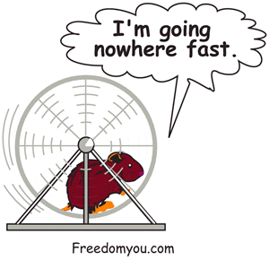
Your daily routine shapes your life. For most of us, we are running like rats on the treadmill of existence, living weary lives, going nowhere and never having enough time to get there. The rat race needs to lose a rat. Get off the rat treadmill and design your own. Design it for increasing challenge. Work towards having a great routine.
Take some time to write out your present routine, then write out your ultimate routine. See yourself living it; feel the pleasure and the joy of the accomplishment.

The secret of life is that there is no secret. It's all learning. No magic pill will change your life. You have to do it one step at a time, one day at a time, one moment at a time. You are rebuilding a life on a new foundation. Investing the time, work and energy to reshape your thinking and life will become much less painful. You will come to see life as a gift from God, an opportunity to experience, and a challenge to grow. Your soul will rise up as though on the wings of an eagle.
Now, let's look at some overeating patterns and some easy changes that will have a big effect.

Overeating Has a Pattern
It is grocery shopping day for Susan. She buys a few treats telling herself “I won't overeat.” When she gets home, she's in the grocery bag for her favorite delicacy—warm cinnamon buns. She should have had one, but she had three. She eats a light dinner because she's not hungry, then spends the night watching TV and makes endless raids on the refrigerator. By the end of the night, she is completely stuffed.
A week later Susan is on a backpacking trip to the mountains. She feels free of food addiction. She is eating sensibly and feels that she has overcome the problem. But she is disappointed when she returns to her usual surroundings.
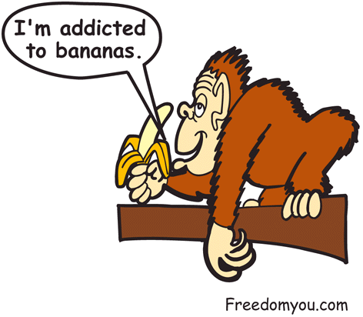
A drug addict will feel no desire to use drugs when in the hospital or in prison, only to experience the full power of addiction on returning to the streets. Entering their familiar environment, they quickly slide into their old routine. In the same way, compulsive eaters usually struggle the most with food addiction in the home because they have established triggers through years of repeated behaviors: chocolate for depression, potato chips for loneliness, pizza for entertainment, cookies for boredom, ice cream for hopelessness, coffee for tiredness. When our routine is controlled by a series of triggers, we feel out of control, no longer master of our life, but a slave of the stomach god. Like a cruel dictator, it growls and we jump to serve its every whim with quiet submission. Time for a rebellion.
Draw a page into three columns. For a few days, write out when you ate, what you ate, what you were thinking about, and why you ate it. Examine the triggers and decide how to control them.

FOOD | WHEN | WHY I ATE IT | MY THOUGHTS

Creating a Routine

When we change our routine, we feel out of balance until the body and mind adjust to the new routine. Once you have the routine you like, it is just a matter of maintaining it. It is like riding a bicycle: once you start, it is easy to keep it going.
Even the smallest changes in routine can mean a huge difference in how you will feel 15 years from now. Eating just a little less, exercising a little more, stretching, lowering body tension, praying ten minutes a day and thinking encouraging thoughts all have a cumulative benefit.
When you reach old age, you will reap the cumulative effect of your lifestyle. You can be running the Iron Man, being an inspiration to everyone you meet, or a miserable old grouch, a joyless, hollow soul, bankrupt of life. For many, the final destination of their daily routine is sickness and misery. Here are some simple ideas to help you avoid it.

Get Focused in the Morning
Write what you want to accomplish the night before, and see yourself achieving it easily. Create enthusiasm to accomplish the work. Spend a few moments in prayer. A short period of stretching exercise or a short walk will also help get you focused.

Worst First
When I worked installing aluminum siding on houses, we always left the worst till the last. I would look up at the eaves through three stories high and think, “I am going to hate doing that.” When I finally got to doing the work, it was hell and I hated every moment.
We try to avoid facing confrontations, problems, hard work and our addictions, but when we do, it feeds into our worries and fears. Face your fears and problems head on. Do the worst first. You will win. You will feel good that you faced it. Then the rest is the easy stuff.
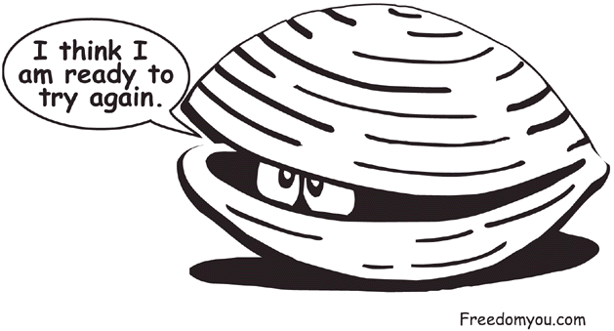
When you are making changes, decide which things are the most important to change first. When you work, do the worst first and get it out of the way. If it is a conflict, face it as quickly as possible. If it's a problem, decide what you can do, then do it. The more a problem is causing you worry, the more important it is to resolve what you can do and start doing it.
Face the worst tasks first. Work on high priority problems and goals first. Do what can be easily done that will have the biggest impact. See the end result and desire it. Focus on what you can do. Don't waste time dwelling on your failures and problems. If it is a decision, get it down on paper, look at all the factors, make a decision, and then refuse to worry.
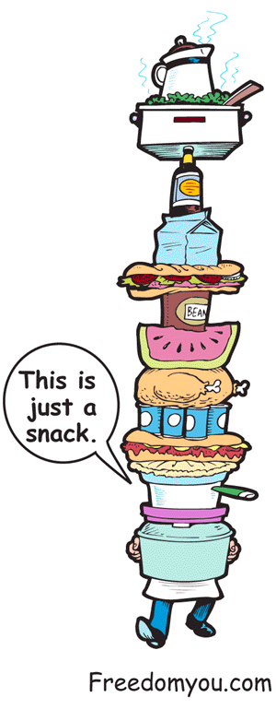
Face fear head on. You can do it! Make a stand. It may take everything you’ve got. Your knees may be shaking. Emotions may be screaming and every thought shouting, “I can't.” Tearful eyes see nothing but a long list of past failures. Ears echo with mocking voices. Meanwhile, you feel as courageous as a wet dew worm. But don't give in. The hardest steel faces the hottest furnace. You will come out the other side tempered, refined and purified. You have nothing to lose but the dross in your life.

Shop With Discipline
What you buy you eat. Don't buy foods that tempt you to overeat. If you buy only healthy food, you will eat healthy food. Shop with discipline. Just going shopping will not work. You have to prepare yourself to face walls of temptations and smells. Plan what you are going to buy, and be ready to resist buying anything else. See yourself shopping, ignoring temptations, coming back with healthy food and making a fruit salad. Expect shopping day to be tough. Remember to feel good about getting past the candy bars and bakeshop. A small amount of discipline in this area can have a big effect on diet.

Arriving Home
The weakest time for most people on a diet is getting home after a hard day. We may be tired and irritable from the stress of travel. The phone rings, your spouse complains about the bills, the kids are screaming and the dog is barking. All we want is to loosen up and unwind; instead we enter a battlefield. It is easy to let our guard down, grab something out of the fridge without thinking and overeat.
Coming home from work, we want comfort. There are ways of getting comfort that are more beneficial than grabbing the fastest available food. Relax with a peppermint tea, unwind, take a shower, spend some time in prayer, do some stretching, take a short walk. Develop healthy ways of recharging your battery.
It is good to prepare your mind for getting home. Decide to be at peace and not let things bother you. Decide what you are going to eat, see yourself eating it and feeling good about it.

TV
TV is a food trigger. The refrigerator is close, and food commercials are running 200 images per hour into our cerebral cortex. Ever become bored during commercial time? The path of least resistance leads to the refrigerator. You need to put a few obstacles in the way. If food commercials are a trigger, watch nature shows or commercial-free TV. If you are just grabbing anything out of the refrigerator, make something healthy like cut veggies and leave them in the fridge. If boredom during the commercials is a trigger to eat, get some hand-weights and do some exercises, play an instrument, read a book, do some stretching, anything but walking to the kitchen.

Escaping the Table
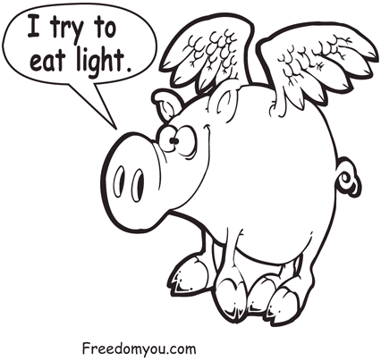
Hanging out at the dinner table is a sure way to overeat. Have an activity that you want to do after the meal. Start to visualize yourself enjoying that activity as you are finishing eating. If it is going for a short walk, imagine yourself enjoying the fresh air and sunshine. Imagine looking at the birds and feeling refreshed. When you imagine an enjoyable walk, you will easily move from eating, to get ready for the walk. Whatever you have chosen for your next activity, imagine yourself enjoying it.

Avoiding the Triggers
Most of us are overeating for a hundred different reasons. We are eating due to stress, irritation and frustration. It may be worry or overwork. We eat because our stomach feels ‘blah’. We are eating out of habit and with no real direction or thoughts about what we are doing with our face in the fridge. Here are some strategies to stop the unhealthy triggers from controlling our life. Psychology calls these techniques avoidance strategies. They are used when we get the urge to eat. The urge will pass, but we need to do something else until it does.

- Imagine a stop sign, and say, “No, I am not letting myself get away with it.”

- Breathe a deep breath, hold for a few seconds, then breathe out slowly and relax.

- Brush your teeth.

- Drink two glasses of water.

- Eat an apple.

- Do 20 sit-ups.

Seat Exercises
A couch potato’s dream: exercise without leaving the sofa. Find a sitting position that is comfortable for you. Now, stick out your leg in a horizontal position and stretch your big toe out as far as it will go. Hold for 30 seconds or so. Now relax your leg and let the tension flow out of it. Stick out your leg in a horizontal position again and twist your foot as far left as it will go and pull your toes toward you. Relax after thirty seconds. Extend your leg again and twist your foot to the right and pull your toes toward you. Do the same action with the other foot. If your arms are stiff from typing or working at a desk, stretch both arms above your head as far as they will go. Stretch your fingers upward. Breathe deeply and relax. Hold this position for 30 seconds to 2 minutes.
You can tighten any muscle group for three seconds: biceps, triceps, and even your butt muscles. Tighten for three seconds then release. Cover the entire body in a systematic manner. Legs, back, stomach, arms, and don't forget the jaw. Tighten your shoulders by shrugging, then relax. Extend your jaw as far as it will go and hold for a few seconds. Stretch your neck up and tense your neck muscles. Concentrate on your face muscles. Tighten them by squinting your eyes, and tightly contracting your forehead and mouth. It will look as if you have just eaten a lemon.
Any exercise or effort will distract you from eating, and give you a workout to boot.

Walk
Walk the block for invigoration. That mini-blast of oxygen will vanquish tiredness and mental exhaustion. Leave your worries behind and be in the moment. Look at the birds. Be thankful. Let go, breathe deeply and relax. You may discover God has always been with you!

Calisthenics
Great for stress release. Helps dissipate excess nervous energy built up by obsessive thinking or stress. Stretching cleans out the lymphatic system, conditions the tendons and joints, and stimulates the organs. Focus on being relaxed, thinking encouraging thoughts, being at peace and prayerful.

Play an Instrument
Easily done if you are at home. Playing an instrument changes the focus of your thoughts and can burn excess energy. If you sing or play happy songs, it will help break the mood of depression and worry. Keep your thoughts encouraging as you play.

Read
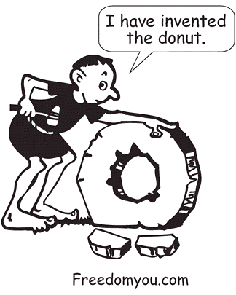Can give mental stimulation or relaxation. Reading short stories, a devotional, or just a few verses of the Bible can encourage you and lift a bad mood.

Prayer
In the humility of being on our knees, we draw on the highest strength: the strength of faith. The greatest tool to challenge mood. It can be done while walking, exercising, or at any time. It is calming before sleep, reduces anger and dissolves pride. Prayer reduces stress better than a tranquilizer. It combats fear, worry and distorted thinking. Kneeling on a cushion while leaning over a chair or a bed is a comfortable position. You can put a towel or a blanket over your head to give you a feeling of seclusion.

Clean Up
Your house or office reflects your attitude. Dirty dishes and piles of paper say one thing: this person is unorganized. Organizing is an investment in the future. You reach for something, and it is there. Many people who are depressed and worried let their house and personal hygiene go. Cleaning and getting organized is the opposite mode. It feels good to have your house clean and your life organized. Cleaning can be stress reducing. You can enjoy it. Use a ten-minute break to organize or clean. Do not get frantic trying to get it done. This is "time out" cleaning where the goal is to enjoy it by feeling good about what you have done.

These are only a few ideas of many that you can do to put an end to unhealthy triggers. Rather than stand in front of the refrigerator, fighting painful battles, take a mini-break. They are the pauses that refresh, peaceful moments in the storm. Time for you to recharge so you have the mental staying power of an Ever-Ready© bunny.

Chapter 13

God Power

The mind is the battlefield. It is a place of dread where a solitary soldier must cross a minefield of worry. But you are not alone. God is with you. Armed with a vacuum cleaner in one-hand and Godly thoughts in the other, you take on Goliath with weapons of patience, faith and hope. You can be improving your thought life while vacuuming, picking veggies in a grocery store or weeding the garden. You can do it while standing or sitting. Every time you change from a negative thought to a positive one, you have gained a victory.
This is not easy; self-defeating thoughts have become routed in your thinking. It takes work, there will be times when you want to give up, but do not quit. When you win, the payoff is gigantic. Peace, hope and feeling loved all come through winning battles over negative thoughts.

Finally, brothers, whatever is true, whatever is noble, whatever is right, whatever is pure, whatever is lovely, whatever is admirable — if anything is excellent or praiseworthy — think about such things. Whatever you have learned or received or heard from me, or seen in me — put it into practice. And the God of peace will be with you.
Philippians 4:8,9


Godliness is the fruit of a pure thought life. The desire for sin falls away. Joy comes and we are blessed in everything we do. When you are blessed, you can be a blessing to others. Isn't that how you want to live? Free like a bird soaring on the winds of joy? Fluffy white emotions glide by as you fly on the wings of pure, peaceful thoughts.
Challenge your negative thinking. Refuse to give in to nagging, complaining emotions. Say to yourself “I am precious, God loves me.” When doubt says, “how can He love me after all the bad things I have done,” look at Romans 8:1, Therefore, there is now no condemnation for those who are in Christ Jesus. If the book says it, believe it. The next time that doubt shows its ugly insecure face, you can say “No! I am forgiven and that is that.” Feel good about it. Thank God for being forgiven. When you are down and the world seems bleak and full of problems, believe what the Bible says:

We demolish arguments and every pretension that sets itself up against the knowledge of God, and we take captive every thought to make it obedient to Christ.
2 Colossians 10:5

If God is for us, who can be against us?
Romans 8:31-32

For God did not give us a spirit of timidity, but a spirit of power, of love and of self-discipline.
2 Timothy 1:7

Think good, encouraging thoughts and you will have peace. The mind easily goes into the worry mode, mulling over all the gloomiest details.
When faced with a problem, get the facts down on paper, and then make a decision about what you are going to do about that problem. When you are tempted to worry, you can say to yourself, “No, I have made a decision. This is in God's hands. Worrying will not help.” If you want to do something positive, pray about the situation, but pray believing that God is working it out. Visualize a good outcome to the problem and see yourself thanking God for answering your prayers.

The work of God is this: to believe in the one he has sent.
John 6:29

To serve God, you do not have to go to the Amazon jungle as a missionary. The work of God is to believe in God's message to you. You are His child. He loves you. He has prepared a place for you. You are forgiven. He will protect you. He has promised to bless you. Do you believe it? If not, start telling yourself “the Bible says I am loved, and I believe it.” Get emotional, rouse up some passion, and get angry at negative thoughts. Refuse to think that way. Don't just go along for the ride. You are in charge. You have control over your thoughts.

Commitment
When love fades, it is commitment that holds a marriage together. Commitment holds the marathoner to that last mile. Commitment draws on strength that we never knew we had. The apostle Paul says to commit our lives to God. Set it apart for His purpose. Commitments challenge us to do our best. Challenge us to be patient and persistent. Challenge us to ignore our feelings and press on. Dedication to God is sealed with commitment. Make your diet a commitment to God.

My Commitment to God
“I make the commitment to turn my diet over to You, Lord. I will eat my food thankful for what You have done. All this delicious, nourishing food is from You; I will take my time to relish every part of the blessing, from preparation to doing the dishes. I have a lot to be thankful for. I will try to eat the right amounts and enjoy each bite. This is my heart's desire. I have been a slave to food and have battled with compulsive eating. Fear and insecurity arise when I feel hungry. Yet, I need to face it head-on, knowing that You are with me. Eating natural foods is the healthiest diet for me. I want to feel the way You intended me to feel. I know that this is Your desire for me. You have designed fruits, vegetables, seeds and grains, for the health of my body. So, I want to eat the way You intended me to eat. I give my diet to You as a gift. I am denying myself so that You may have more of me. Instead of food, I will rely on You for my peace, my joy and my pleasure. This is my commitment to You.”

Confessions for

Fighting Temptation
- “God's power is greater than my sin nature. When I resist sin, Christ moves into action. I have been given the authority to control sin and I am using it.”

- “This temptation is a test of loyalty to God. I will pass it.”

- “This trial I am going through is a gift.”

- “I am willing to suffer physical discomfort. My suffering for Christ will turn to joy. You have suffered for me. In this, I suffer for Him.”

- “This temptation is empty. The more I want, the more it causes me pain. I have decided to sacrifice all, wanting nothing, but to know Christ and let Him fulfill my needs.”

- “There is no pleasure to expect from eating wrongly. My anticipation is stupid. I am increasing sin's power by anticipation. I am becoming excited about anticipating something that is not real.”

- “I do not accept this negative emotion, thought, feeling or anxiety. I will not believe a lie.”

- “I repent. This desire is a sin. I have no excuse. Please, help me, Lord.”

- “I am taking Your way out Lord. There is a way out of every temptation.”

- “Overeating is gluttony. It is a sin. In stuffing my body for pleasure, I am abusing the body God has given me.”

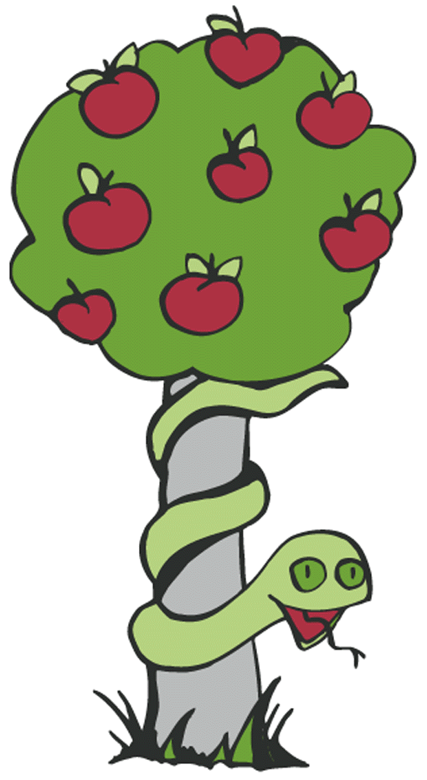
- “Food cannot fill the feeling of emptiness, only Christ can. The more I use food to run from inner pain, the worse it gets. I need to face it with courage. Insecurity, fear and doubt and worry of the future will not rule me. Christ has promised to supply all my needs according to His riches and glory. He is the Source of joy. He is the Source of peace. He is the Source of love. The more I draw close to the Source, joy, peace and love will come.

- “I am a new creation in Christ. God has recreated me into an eternal being. The Creator of the universe lives in me and I am free. I am free of addiction. I need nothing from this world. I am content with what I have.”

The Bible and Junk food
What does the Bible say about diet? Very little, it wasn't a problem two thousand years ago. All food was organically grown, free of additives and used fresh because they had no refrigerators. Christians walked miles every day. The early church didn't need adrenaline stimulants and donuts to get the meeting going. If Paul were alive, he would definitely address the problem. Here is what I think Paul would say if he were here today.

Paul's letter to the church of North America
- Eating junk food is a sin against your body. If you know it is harmful and you are eating it, you are sinning as you are not being a good steward of your body, God’s creation. You are living according to fleshly desires instead of discipline and wisdom. Don't you know that the body is the temple of the Holy Spirit? Should we use the temple of God for personal indulgence? No! You do not belong to yourselves but to God; He bought you for a price. So use your bodies for God's glory.

Chapter 14

Quit Day

It's going to be war. Time to rally courage. Why do you want to win? Is it important? Are you ready to pay the price of pain for freedom? Can you see the victory? Do you want it? If you are saying “yes” with burning desire, you are ready.
If you are not ready to quit, don't even try. Quitting for a few hours or days is only a tease. It intensifies the desire. Almost quitting reinforces the addiction and strengthens the attachment to food.
The only effective way of ending an addictive behavior is to stop it. Anything less will only increase the addiction, making it more deeply engraved. You have to win the first time you try. No half-hearted effort will do. Struggling and losing will painfully increase the power of the addiction. When we fail with quitting an addiction, we come face to face with our helplessness and loss of control of our life.

Bad Food Hit List
Write out a list of the foods which you eat the most and rate them one to ten, with ten being healthiest. The toxic, high-fat foods go at the bottom of the list. The nutritious foods that agree with you go at the top. Write a line beside each food describing its qualities and effect on your body. We have a tendency to forget the bad qualities and remember only the flavor. We might like the taste of beans but forget how much we hate the gas problem. We eat chocolate, then remember its effect when a mountainous pimple appears on our nose as a reminder.
Decide which foods are the worst offender to your health, and score it off the list. It may be potato chips or french fries. A few times each day, encourage yourself by saying, “I am french fry free.” Take the time to feel good that you have removed that food from your diet. Remind yourself why you have crossed it off. We think of junk food and addictive drugs in the same way; we forget the harmful effects and remember only the good. By remembering the harmful qualities of that food, it keeps you focused on why you choose not to eat that food.
I was addicted to bread. I loved the smell of toast. Banana, honey and peanut butter made it complete. But bread causes an intense reaction. It made me sleepy and unfocused. For me, eating bread was like using a drug. Numerous friends would comment on my condition, only to raise an eyebrow when I said, “I ate some bread.” I would wake up with my skin and eyes puffy. I hated what it did to me but loved the taste. One day I woke up particularly out of it and my friend, noticing my state, jokingly called me, ‘bread man.’ That was it; the bread was in the garbage. It was war. This stuff is out of my life. It was the point of having enough, and the term ‘bread man’ engraved my mind with the image of a spaced out bread junkie.
That is how you must see yourself: in the worst light. Look at how bad your addiction really is. It is humiliating that you are stealing your dignity. Remember the worst experience of feeling stuffed and bloated with gas, suffering from greasy skin and heartburn. See addiction to food for the ugliness it is. It has to go. Addiction has mocked you for the last time. You are up for the fight. You will not lose. You have the tools, the desire and the knowledge. Goliath is about to face David!

Getting Started Check List
- Buy nutritious food.
- Know triggers and weaknesses and have a plan to deal with them.
- Decide on an exercise program.
- Write your reasons for quitting.
- Take steps to make the first few days hassle-free.
- Share your intention and ask for the support of a friend.
- Have quiet times to strengthen your resolve.

Journal
By the time we graduate from high school, we will have learned and forgotten several million facts. Most facts were worthy of forgetting, but writing them down keeps the most important ones. In your journal write the lessons you have learned, the good that you do, the good that happens to you, insights, successes and mistakes. Consider each day, then review to see how you are doing. When you consider the day, encourage yourself with your successes and bring the mistakes into perspective. Observe patterns and look for ways to change those patterns. Recovery is not a straight-line process. If you were to chart your progress, it would look like the graph of the stock market. Just when you think you’re doing well, the graph takes a dip. So expect it. Writing in a journal will give you a better perspective on life. It helps you look at the bigger picture and see how you are getting there, one step at a time. It will remind you of all the little things you have accomplished and bring the mistakes into perspective.

Chapter 15

What to Eat

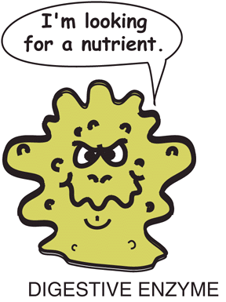
We are the only creatures on earth that cook food. Cooking kills not only the enzymes but it kills us. The effect is slow and gradual, but inevitable. Cooking alters protein and fiber, destroys vitamins and minerals, and kills all enzymes. Nutrients we desperately need are being destroyed.
Raw food is the key to health. As those natural fibers enter the stomach, it lets out a sigh of relief. “Finally, a meal easy to digest.” Stomach enzymes discover the rich abundance of nutrition supplied by the hand of God. No pizza sludge, no dead animal parts, no chemicals, no grease, no sticky white flour goo, just a gold mine of nutrition. Happily, the stomach enzymes release their precious cargo into the blood. It’s Christmastime for the 3 trillion cellular residents of the body.
Have you ever lived through a garbage strike? Garbage is everywhere. Every corner and crevice becomes a storage spot. Flies and putrid odors abound. It's a sigh of relief when those guys go back to work. Eating raw food ends the ‘garbage strike’ within the body. In the stomach, organs have been overloaded. Every day it has endured forced labor, carrying loads of toxic fat, cholesterol, animal flesh, additives and foods saturated with sugar and salt. Sickness is the bodies’ garbage strike. It is protesting against being overworked and underpaid nutrient-wise.
The cells cheer the first meal of raw food. No more heavy digestive work. Lots of high-paying nutrients. The strike is over. Every cellular resident goes on a garbage cleanup, removing the leftover pizza sludge, chocolate bars and cola residues. The T-cells dump billions of molecules into the blood to be removed. You feel like garbage because your bloodstream is overloaded with toxic waste. After feeling bad for a day, and possibly suffering a headache, the toxic mucus slime of overindulgence is gradually removed from the body.
Remarkable things start to happen: periods of exhilaration, energy and clarity of mind that will testify of God's intention for us to be exuberantly happy and abundantly healthy. But this is only the first experience of the greater benefits yet to come.
Weakness, headaches or dizziness are common symptoms of detoxification. Even one day on fruit can cause bloating, gas, diarrhea, indigestion and a feeling of weakness. Your faith and patience will be tested. It is so easy to return to one's former diet, thinking, “raw food does not agree with me.” Realize that your body has adapted its enzyme secretions to whatever you have been eating. If you ate a high-meat diet, you will have demanded the body to create a large number of cells that produce hydrochloric acid needed to digest meat. The stomach will have developed a thick coating of mucus to protect the lining from hydrochloric acid that is so strong it can eat through metal. Then you change your diet. Instead of eating a steak, you eat three peaches and some grapes. Although fruit is easy to digest, it requires very different digestive secretions than a steak. Your body reacts by sending you to the bathroom for most of the day. As you eat more raw food, the body will, over a few weeks, increase the cells needed to comfortably digest fruit. The fruit will then digest without gas, diarrhea, or any discomfort whatsoever.
If you eat a large steak after 6 months of eating a light diet of raw food, the steak will sit in the stomach like a lead brick, as the stomach has become adjusted to lighter eating. Eating a heavy starch meal will fill the sinuses with mucus. Eating cheese will cause constipation. A greasy meal will cause headaches, tiredness and oily skin. The body is reacting to your old diet as if it were poisonous.
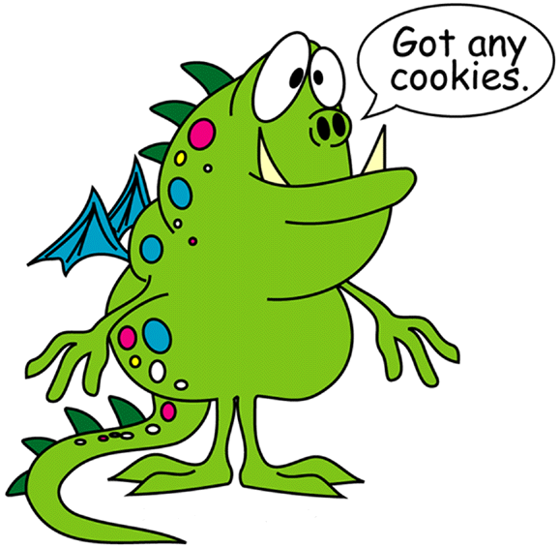
If you are eating the standard North American diet, your body has been functioning abnormally. The blood, digestive secretions and the biochemical balance of the body have become adjusted to function as best it can under a barrage of toxic food, caffeine, saturated fats and heavy proteins. Change that balance and the body reacts as it would to any addiction. It will crave salt, sugar, coffee, tea, white flour, chocolate, tobacco, pepper, meats, fried food, or whatever foods have become the mainstay of your diet. In this state, your body will never crave fruit or vegetables. You will never be caught in the refrigerator at three in the morning, raiding it for cantaloupes, because you are addicted to toxic foods.
Man makes food to be addictive. The industry profits as your health deteriorates. God makes food satisfying, nourishing and cleansing. Money is useless in heaven. He cares about your health because He loves you.
When cravings hit, it’s time to hang tough and have faith. The body will rebalance, and the desire for that favorite junk food will disappear. We recommend 30 days of eating nothing but raw fruits and vegetables as a way to regain control over food. By the end of this period, all unnatural cravings will have disappeared and you will discover a health and well being that will surprise you. Eating raw food for thirty days is a true challenge, but if you use your newly discovered skills, you will joyously succeed. And when you do, the gain will be a blessing to you for the rest of your life, a gift of God.

Oops! I forgot to eat!
No more getting pushed around by those evil munchies; now you are in control. As you flex your new muscles of discipline, you will face hunger, just for the fun of it, and shrug off its demands. Oops! I forgot to eat!
The body enters the fasting state.
In the fasting state, you are forcing the body to use fatty tissue and glycogen reserves. The good part is that you will lose pounds of ugly fat and cleanse toxins from the body. Years of drug residues, junk food, chemicals, environmental toxins, rancid oils and fats do not leave the body comfortably. Expect to experience headaches, weakness, dizziness or light-headedness. You may chill more easily and feel more sensitive. This is not harmful, just part of the process of cleansing. Toxins in the bloodstream cause the eyes to glaze, the tongue to become coated, and the breath to become fowl. When this waste is removed, you feel years younger and full of life. This cycle may occur several times during a long fast. Each time you feel toxic expect to feel amazing once the toxins are cleansed form the system.
Fasting is easy because you lose all desire to eat. Food looks like rubber. It is nauseating even to look at it. No food can tempt you. When your body enters the fasting state, it wants to finish the work. Hunger can disappear for weeks at a time. Cleansing the body takes time; it will take a 30-day juice fast to completely rejuvenate the body. Something we thoroughly recommend. There are only a few health conditions that restrict juice fasting, as the body is receiving an abundance of calories, enzymes and nutrition. It is not starving because your body has 3,500 calories stored in each pound of body fat. We are carrying around a backpack full of groceries.
If you lose all desire to eat, and the cleansing has become discomforting, there is a simple solution. Eat a little more or drink juices from a juice extractor. The added calories will slow the cleansing process.
Eating 100% raw fruits and veggies will start the process of cleansing. Using the mental skills in this book will cleanse negative thoughts from your thinking. Every cell of your body and millions of neurological pathways are being readjusted. There will be periods of feeling out of balance. You may occasionally become irritable and edgy. Your endurance will be tested. If you are intent on being determined and persistent, you will have the fortitude to meet every challenge head on. Know that what you are doing is right before God. In heaven, Christ looks down, smiling at a star in His universe.

To become familiar with fasting, read the book Fasting to Freedom, the fourth book in this series.

Chapter 16

How to Eat

Get those dopamine pleasure molecules working overtime by really savoring each mouthful. The more you enjoy the experience of eating, the more satisfied you will be. The more you enjoy it, the easier it will be to establish it as a behavior.

- Prepare. Get your food in advance and put some energy into making it appealing. You will enjoy it more if there is anticipation. Spend some time looking at it and enjoying the colors and smells. Even if you eat a cantaloupe, cut it into squares and chill in the freezer for 15 minutes.

- Eat Hungry. We eat three times the amount of food we need to maintain health. The food most people eat in one day could sustain an entire family in Africa for one day. Do not confuse natural hunger for cravings. A growling stomach with a ‘blah’ taste in the mouth is not hunger. Eating to relieve grumbling, gastric irritation will leave you feeling sluggish and lethargic. Wait until you are hungry. You won't die of starvation. You can do it. Most people have experienced true hunger only few times in their life. Face hunger. It may seem like Goliath, but if you put up a fight, he'll run. If you are not hungry, miss a meal. Skip breakfast or the occasional meal and feel the intensity of hunger as it builds readiness. During hunger, the sinuses clear, the stomach becomes ready and sense of smell becomes acute. Best of all, taste is enhanced. Eating hungry gives more satisfaction, even a burst of energy and a feeling of well being if you eat healthy food. Wait until your body needs nutrition, eat raw foods, and chew your food well. If you eat this way, you will not have the desire to keep eating, but will be satisfied with smaller portions. And, that is the way it should be. If gastric irritation becomes uncomfortable, eat a small amount of fruit or vegetable to help relieve it.

- Chew, Chew, and Chew. Isn't chewing great? It’s way better than swallowing. We make swallowing the big event, but it's the anticlimax. Chewing is the build-up, the anticipation. As the digestive enzymes in saliva start their work, the food changes flavor with each chew exploding more taste sensations. Soft warm textures massage the tongue. Digestion starts in the mouth and so does contentment. Explore chewing, it is a mouthful of excitement. It greatly increases the health value of the food. Aim for thirty chews to the gulp.

- Eat Stress-Free. A plate of worry is bad for the belly. Turn on some relaxing music and take your meal to bed. Go outside if it is warm. Let go and be at peace before you eat. Slow down, do not rush, and enjoy each mouthful. Do not let your mind drift to problems and worries. If you are going to eat, pay attention to eating. If you are going to worry, stop and worry. Give yourself a few minutes to worry and get it out of your system. Be present; be aware of the taste, of your breathing, of how the food feels in the stomach. Enjoy the experience as much as possible. The more you enjoy it, the more satisfied you will be.

- Feel Good as You Eat. Feel good about your accomplishment. You are eating health-giving food with discipline. Be proud of that accomplishment. Take the time to enjoy being content with feeling full.

- Be Thankful. Think of what God has given you. He loves you and is sustaining you. He is with you as you eat. You are surrounded by the blessings of God. Food has been brought from all over the world just for your benefit. We have much to be thankful for.

- Love the Foods that Love You. Look your food straight in the eye and ask it a question: “Do you love me? Will you support my cells and care for me in old age? Are you loving my body or is your love artificial? Do you really love me or are you just flirting with my taste buds?” If you want to be healthy, love the foods that love you.

- Eat Simple. The silkworm lives on mulberry leaves. The koala lives on eucalyptus leaves. Cows live on grass and do just fine. Humans are the only creatures in the known universe who eat every food type in the same meal. Because of it we burp, expel gas and kill our colon with abuse. Stomach ulcers are just part of the fun. Pretend you are in Eden and enjoy eating from one tree at a time. Aim for a simpler diet; your stomach will love you for it.

- Eat in the Raw. Cooking kills! As you drop your veggies into a pot of boiling water listen closely. You can hear the enzymes screaming with pain as they die. That poor little enzyme was just trying to build your health. Your body and mind will feel amazing if you can get your diet up to 80% raw. Give enzymes a break. Sell your pots and pans.

- Spice is Not Nice. Overuse of spices is hard on the stomach. Salt and white vinegar is addictive in excess. Food becomes tasteless and bland without them. Use condiments in moderation.

Chapter 17

Thirty Days to Freedom

A 30-Day Program to Combat
Compulsive/Obsessive Eating.

We recommend 30 days on raw fruits and vegetables. Raw food is used by sanitariums in the healing of disease because it is similar to a juice fast in detoxifying the body. The process is slower, but the effect is the same; you will be revitalized. If you stick to this program, you will experience an exhilaration that you have never known. You will feel vitally alive. As your blood clears of all addictive substances, you will feel great. Any health conditions will be noticeably improved or even healed. Your sinuses will clear of mucus and you will be able to smell even the faintest of scents. You will be able to breathe deeply, feeling each breath enter the lungs. The mental fog will lift and your mind will become more alert. Your skin will soften and feel sleek. You will feel 10 years younger and look like it.
Raw food is loaded with enzymes, vitamins and minerals. For the first time in your life, your body is functioning free of heavy proteins, milk fats, animal fats, cholesterol, mucus forming starches, trans fatty acids, food additives and high doses of salt and sugar. You have given your body a time of rest and healing.
The first week will be the hardest, especially the first few days, for that is the time when the body undergoes the most intense cleansing. As the weeks progress, you will feel better and better.
Although juice fasting is superior in its healing effect, the challenge of a raw food diet is better than juice fasting at developing the skills to control food intake. When a compulsive eater juice fasts, he feels free from food addiction, but as soon as he starts to eat, hunger triggers all the compulsive desires and distorted thinking patterns that were never dealt with. The result is a binge. The benefit of a 30-day fast can be lost in three weeks of indulgence.
Juice fasting has more amazing benefits than a raw food diet, but first you must develop the skills to combat compulsive eating. By occasionally replacing meals with fresh-made juice, you are gaining the benefits of juice fasting while battling compulsive eating. For this reason, juice is an important component of the raw food program. Try to have freshly made juice each day.
In our book, God's Banquet Table, you will find juice recipes, fruit recipes, blender recipes and raw vegetable recipes that will make your thirty days a pleasurable experience. The book also includes raw nut recipes, grain recipes and bean recipes and, although these are healthy in moderation, wait until the thirty days are over before adding them to the raw fruit and vegetable diet.
Thirty days of raw food is a challenge that will powerfully affect your life. These diet restrictions are difficult to face, but in doing so; you will bring about healthy changes that will benefit your body and mind. Healthy changes are an investment in your future.
The raw food diet includes:
- Raw fruits and vegetables
- Fruit and vegetable juices
- Herbal teas
- Honey and natural sweeteners
- Frozen juice concentrates
- Frozen fruit

Preparation for the Program
Read the book before you start. Buy the produce you need. Buy a food processor, blender and juicer. Create some raw food recipes you enjoy. Make the 30 days a commitment before God. Spend time in prayer. Draw on the strength of faith.
Build your resolute decisions. Find a friend who will do this along with you so you may support each other. Tell those who will be affected by your decision how much this matters to you, and ask them for their help and understanding.

During the Program
Read this chapter once per day. Write out some points that you want to work on for that day. Constantly remind yourself of the reasons you are doing this. Remind yourself of what you have suffered by being a slave to food. Refuse to allow your mind to think negatively. Be intent on making each thought a positive one. Refuse to put yourself down. Always build and encourage. Ponder, pray, read, study and invest energy; the more you put into it, the more you will get out of it.
Get focused in the morning, especially with prayer. The first thing to do while getting out of bed is to do some exercise to get the blood moving. This works faster than coffee. Take a shower and at the end, run the water cool or cold. As you face the discomfort of the cold water, strengthen your mental stance for the day: “I refuse to eat donuts. I refuse to drink coffee. I refuse to be negative. I refuse to worry. I refuse to be lazy. This is going to be a great day.” Start a journal to keep you objective in seeing your accomplishment and failures.
Try to feed your mind with positive input. Choose educational programming on television. Cut down on reading newspapers. Much of it can be negative. Cut down socializing with negative people. Don't read horror novels. Develop a workout routine. Go for relaxing walks to be at peace and encourage yourself. Spend quiet time outside or alone where you can be at peace with God.
Cut out the negative influences on your thinking. You need to strive at being active in your thinking process to work at fighting negative thoughts. This will take time.

During Eating
Plan your meals ahead and put some energy into making the meal appealing. We go overboard for our guests, but ignore our enjoyment by eating from the refrigerator or cupboard. Try to clean up before you eat so you will not have a chore that can be an excuse to keep eating. Wait until after the meal before you drink. Herbal tea is relaxing; it will help you move out of the mode of overeating. Look at your food before you eat it. Tell yourself how good it is going to taste. Relax, you do not have to eat right away. Wait a minute before you eat to get focused on the food.
Eat predetermined quantities, no more. Chew your food well. Slow down and relax. Do not think about problems. Be present with the food. Feel content as you eat. Enjoy your food to the fullest, savoring every bite as though it is the last. Imagine all those nutrients going to your happy cells. Be thankful. Feel satisfied as you finish the meal. Create revulsion if you are still hungry. Visualize yourself enjoying your next activity, then get motivated.

Get Hungry
You can face hunger and be at peace. Ignoring hunger can cause feelings of being deprived that stir up uncomfortable emotions. It may take some prayer to be able to face hunger. For the next thirty days, make it your goal to eat one bowl-full or small portions of food, then wait until you are hungry before eating again. It is better for you to eat several small meals each day than three big ones. Larger meals have a tendency to overload the body with calories that can be turned to fat.
Eating while hungry reduces fat production. If you eat when you are not hungry, the blood is filled with calories and you are adding more, so the excess is turned to fat. When you eat when you are hungry, the body needs calories so there is no excess. If you want to be thin, eat smaller amounts when you are hungry. Put a check mark every time you have waited till you are hungry before you eat. Put a number beside the check mark. Five is really hungry and one is a little hungry. Look at your successes and feel good about them. Each time you face hunger and win, you are conquering food addiction. Hunger prepares the stomach for food. It makes it tastier, and lets the digestive systems have smaller portions of work to do. Eating this way will give you a blast of energy better than that of coffee. Expect more energy. If you lose the desire to eat, you have started to detoxify. If so, you will feel weak for a few hours or days. Drinking freshly made juice will keep your energy up during these times.

Urge Fighting Skills
This battle is for freedom; refuse to fail. You can feel intense emotions and choose not to give in. Tell yourself, “I refuse to quit. I refuse to give in. I refuse to fail.” During the emotional windstorms caused by temptation, ask yourself, “what do I really want?” Eating to relieve stress is not what you want. What you really want is to be at peace. Eating out of anger is not what you want. What you want is to resolve the issue. Eating to relieve fear is not what you want. What you really want is the courage to face it. Eating in the place of boredom is not what you want. What you really want is a challenge that will stir some excitement within you.
Do not fight obsessive thoughts, but deflect them into positive thoughts and activities. Use mini-breaks to change your mood and break cycles of obsessive thinking. Do something you enjoy for a few minutes until the emotions diminish. Play an instrument, exercise, go for a short walk, or do some stretching. Not only will you be fighting obsessive thoughts, but improving your life one mini-break at a time. Do not give in to an urge; each time you do, the pleasure will create a craving to repeat it. Remind yourself that junk food is artificial pleasure that steals from your body. If you do not feed a craving, it will die. If you become anxious take a slow, deep breath, holding for one second, and then release, think peace. Let go and let God.
Create the feeling of revulsion to the point of nausea: finger nails scratching a blackboard, a hair in your soup, dog vomit on your carpet, a wet fur ball on your bed, or a bug in your shoe. Find what image best works for you. Use negative labeling. Bacon is burned strips of cholesterol and fat. Make up your own negative labels for the foods you are trying to quit. Play the mental tape to the end; look at the big picture. Don't look only at the pleasure, but focus on all of the negative consequences.
When we discipline ourselves, we feel as though we have lost something, and feel deprived. Fight that feeling with the fact that you have what you need to be happy. Challenge the feeling of loss.
Remind yourself of the bad qualities of the food you hate. Refuse to eat them. Avoid triggers like donut stores and bakeries. Avoid spending time in the kitchen or at the dinner table when you start to feel tempted. Plan your meals. Have fruit or vegetable snacks ready.
The first few days can be the toughest. If you feel weak and out of it, it will be difficult to discipline your thoughts. Discipline is work, and feeling toxic creates an ‘I don't –care’ feeling. It will pass once the blood clears of toxins. Do the best you can during these times to remain resolute.

Be Resolute
The longer you focus on a temptation, the weaker your resolve will become. You are sending thoughts into your subconscious that are weakening your decisions. In the face of temptation, be firm. Accept that you are being tempted, but refuse to give in. Be stubborn. No arguments allowed. Your decision is final.
We all have a stubborn part of our character that digs its heals in and says, “no, I refuse.” It can get us into a fair bit of trouble. It can also be used to form resolute decisions. Certain thoughts stir that stubbornness into activity. If you were told to rob a bank or run naked down the street, you would stubbornly refuse, even at gunpoint. Imagine if you refuse to eat junk food with that same power of conviction.
It is easier to refuse to do something than it is to try to do something. Which statement is stronger, “I will try to eat better” or “I refuse to eat junk food.” Stubbornly refusing to do something has power. It is absolute refusal that makes decisions resolute.
The second part of a resolute decision is being intent. Being intent is to be fixed on something. Like an athlete preparing for the challenge, be fixed on what you intend to achieve. Do not become distracted. Be connected to the victory, just as an archer aims for his target. All that he can see is that target. Once he has fired his arrow, he relaxes and gets ready to become intent again. The focus is exhausting. It requires 100% attention. Be like that. See the goal and become totally fixed on it for periods of times during each day, especially just before you eat or face temptation. Once it is over, you can relax till the next target comes up.
Resolute decisions end mental wars. Weak decisions are useless. Inevitably, you compromise, then feel like a failure. Make your decisions resolute. Pull out that part of your nature that digs its heals in when it is told to do something it does not want to do.
If you have made the decision to eat one bowl full of food per meal and wait till you are hungry before eating, you have to think of that decision, then create a storm in your soul: “I am not getting pushed around any more. I refuse to be controlled by food. Cravings do your worst. I will not budge. I am standing firm. My decision is unchangeable. I will not give in.” This is war. How long are you going to let this problem go on in your life? Till the day you die? Feel it! A resolute decision is forming.
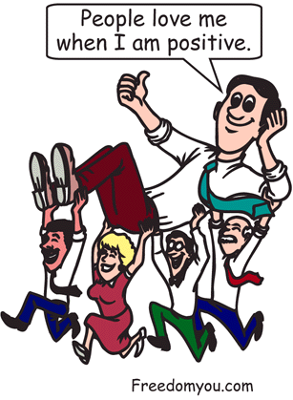
The three important decisions you will have to be resolute about:
Refuse yourself permission to eat anything except raw food. Be intent to finish the 30-day program. Refuse to fail.
Refuse yourself permission to overeat. Be intent on eating one bowl of food or a small portion, and wait until you are hungry before eating again.
Refuse to think negative thoughts. Be intent that you will think only positive thoughts.
These decisions are paramount to the success of the program. Each day you have to go over the reasons as to why you have made these decisions, and strengthen those decisions by reaffirming your intent not to give in: “I will not bend regardless of how I feel. My decision is final.” If you feel weak, go down in the basement, plant your feet firmly on the floor and shout with all your strength, “I will not give in. My decision is made and that is it.”
As soon as you weaken in your decision, the battle starts. Pain comes in, emotions stir to a storm: fear, insecurity, anxiety, feeling empty and deprived. These feelings will not exist if your decision is resolute. They come because you are allowing yourself to consider breaking your decision. Even if you do not break, those feelings will have weakened your decision and you will need to rebuild it. If you do not, you will fail.
Make a list of your resolute decisions and read it daily. Make your diet a commitment to God, and then refuse to go back on that commitment.

Leave The Past
Quit living in the past. You can't fix it. Let it go and decide to move on. Live your life to the fullest. Feelings can be a lie; learn to challenge them by asking questions. “Why am I feeling this way?” Accept what needs to be accepted. Trust God where you need to trust. Let go and let God. Loosen up. Have fun. Allow yourself to be like a child. Don't let the past ruin your future.

Be Motivated
Your thoughts determine how you feel. It is time to change those self-defeating thoughts. Stop all self-criticism. Do not use "should" statements. Do not blame or make excuses for your behavior. Take responsibility, accept and love yourself. Feel good about your accomplishments. Do the worst tasks first.
Refuse to worry, especially during eating. Get the problem down on paper. Be objective. Make your decisions, then stop worrying and do something positive. If it can't be changed, ask the Lord for the strength to accept your situation. Make a list of your priorities and goals. Make a list of positive statements to say to yourself for encouragement. Learn how to create the feeling of joy and peace.
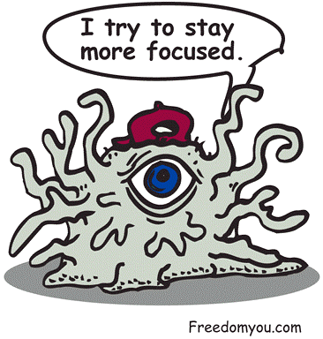Your brain is filled with negative thoughts. It will take work to change the programming. When you do, discipline becomes easier.

Facing Failure
If you fall off the track, do not quit, but be sympathetic to yourself. Allow yourself to fail; it is an acceptable part of learning. Don't make a big deal out of it. Focus on the goal, not the failure. Examine what caused you to fail and come up with ideas to prevent it from happening again. Do not beat yourself up with guilt. Feel regret, then build the desire to change. Feel bad about the decision, then make a decision and move on to your goals. Encourage yourself. Think of the things that you have accomplished.
Blowing it is part of the process of learning how to do it correctly. You are not a failure. You have come so far and accomplished so much!
Fight those feelings of worthlessness. Consider God's love for you. Feel the forgiveness of a Father's love. Forgive yourself. Apologize to God for being so miserable and not asking for His help. Thank Him for your failures and the chance to learn.
Rebuild your desire to try again. Look at all the benefits. Come on, you can do it!

Run Brain Commercials
Fill your brain with pictures that move you forward, inspire, and encourage yourself. See yourself successfully completing your goals. See yourself enjoying your next activity to get moving. See yourself overcoming temptation. See yourself happy and full of joy. Let God have some ‘commercial time’.

Encouraging Scriptures
Psalm 23: The Lord is my Shepherd.
Romans 8:31: About the love of God.
Corinthians 13: The love chapter.
Philippians 3:12–14: Forgetting the past and running the race.
Colossians 3:12–17: Clothing ourselves in Christ.

Take Ten
Take ten minutes to pray shortly after awakening “Lord help me to do this. I really want to. This is important to me.”
Take ten minutes to build conviction to your resolute decisions.
Take ten minutes to consider your accomplishments and feeling good about them.
Take ten minutes to do a visualization exercise.
Take ten minutes each night to journal your day. Bring the failures into context and feel good about your successes.
Take ten minutes to stretch or exercise.

Dessert as a Meal
Most of your meals should be fruit salads. They are easy to make, delicious, and full of enzymes.

Fruit Salad Mix: Freeze peeled, ripe bananas in freezer bags. As they start to freeze, break them up so they will not clump together. Bananas will store in the freezer for months. If you are cutting a frozen banana that is too hard, place it in the microwave for 10 seconds. To eat them like a Popsicle, wrap the bottom with a paper towel. For the fruit salad base, use oranges, melons, grapes, peaches, or the fruit of your choice. Dice the fruit into bite-sized pieces then place in a bowl. Frozen banana slices are added next. They taste like ice cream. Chill the mixture.

Fruit Salad Dressing: The dressing is the most important part. The dressing will make fruit taste like one of the best desserts you have ever tasted, but it will be healthy. To make your dressing, mix applesauce and one tablespoon of orange or pineapple concentrate. Avocados also make an amazing dressing. Avocados are high in calories. They’re perfect if you are an athlete in training or have a fast metabolism and do not want to lose weight during the 30 days. Buy ripe avocados. Test them by pressing with your thumb. They should give a little, but not be mushy. To make an avocado dressing, blend avocados with frozen orange, pineapple or apple concentrate. Frozen juice concentrates sweeten the mixture. You can also use the frozen concentrates as a topping; just mush and spread over the top.

Fruit Salad Topping- Sprinkle chopped dates with cinnamon for the final touch.
These fruit desserts will never get boring. You’ll feel no sleepiness or bloated feeling after eating, but a clean burst of energy. Try to make the mixture ten minutes in advance. Put it in the freezer, clean up and spend a few moments in prayer to be at peace. You will easily appreciate every bite.

Orange-Banana Shake - 1 Banana, 1/4 can frozen pineapple or orange concentrate, one-cup water and 4 ice cubes.

A Bigger Mountain
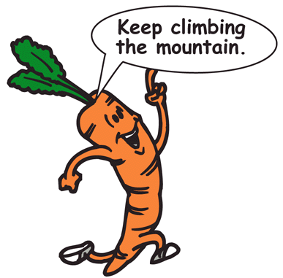
Congratulations! You’ve achieved the thirty days. You're high on life, flying on the jet steams of joy. Every cell of your body is bursting with enthusiasm. Why stop here? The 30 days is just a launching pad. Bigger mountains are waiting. Consider the 90-day challenge. You are already one third of the way there. Your body and mind will feel amazing by this point. Believe that it gets even better. Climbing the 90-day mountain will revolutionize your life more than you can possibly believe.

The 90-day program has three parts.
- One thirty-day raw-food program.
- One thirty-day fast.
- Another thirty-day raw-food program.

The 30-day fast is mostly a juice fast, but we recommend two periods of water fasting of three days in length, or one five-day water fast during this time period. Read our book Fasting to Freedom; there are only a few health conditions that restrict fasting. It is not starving, as your body is being flooded with nutrients. Even during a water fast, the body has 3,500 calories per pound of body fat ready for use. The periods of water fasting are a time of prayer, brokenness, and humility before the awesomeness of God. Water fasting is a period of deeper cleansing. It’s a time to renew conviction and hunger for God. Because your body is clean, you will find these periods easy. There will be a sense of freedom that you have never experienced. Do not expect to feel dragged out; the exhilaration and closeness to God will belie description.
The 30 days back on the raw food diet is the only way to continue gaining more of the same astounding benefits you have received. Most people break a lengthy fast over 10 days. But thirty days is even better. After the 90 days, you can return to cooked food, small amounts of grains, sprouts, raw nuts, and all the delicious recipes we have listed in God's Banquet Table.
May you be blessed in every way, and the favor of God shine upon you. May you be filled with everlasting joy.

Chapter 18

Recipes

It is a brand new day, a gift of God? Are your ready to live life to its fullest? Are you ready to make the best of what God has given you? Before you eat, consider your goals for the day. See yourself accomplishing them easily and feeling good about it. Visualize you enjoying the day. Make a to worry for this day and leave it in God's hands. Decide to be loose and kid-like. Intend to have some fun. When you are ready to eat, take a moment to thank God for His provision. Chew the food well and feel content. Do not let you mind wander, stay focused on the breakfast. When you finish eating, feel good that you have eaten in a disciplined manner.
If you are feeling lonely, challenge the thought. You are not alone. If you feel worthless, challenge it. You are a kind, loving, patient person who works hard at whatever you do. You are not worthless; you are a good person. Be at peace with yourself. Forgive your mistakes. You don't have to be perfect. Let go of those uncomfortable feelings and trust in God. Give Him your
Suffering. You don't need food for comfort. Food can't give what you want. Only Christ can, so ask Him. Believe that He loves you. You are special to Him. He will never forsake you or leave you. Shake up your shoulders, loosen up, let go, and be at peace. There is nothing to worry about. It will all work out. Eat slowly, chewing till the food becomes liquid. Be thankful. Feel satisfied. Feel good that you are giving your body good nutrition.
Snacking is healthy. It is better to eat several small meals a day than eat three large ones. You'll feel less bloated and the stomach has an easier time. Get snack happy with fruits and veggies. Both are low in calories and supply good nutrition without rancid fat, additives or cholesterol. You don't have to eat by the clock. Dare to be different. Eat when you are hungry. If you are not hungry, don't eat. Raisins or dates are a great replacement for the sweetness of candy. Dried apples and pears are far more nutritious than junk food. This takes some getting used to. You will crave junk food for a few weeks, but after that, you will be free to eat the foods that love you.
The cares of the day will steal your enjoyment if you let it. Stay focused on the food. Make the decision to leave any problem in God's hands. If you are tense, take a few deep breaths and release slowly to the word "peace". Don't let your thinking get negative. This is going to be a good day. You're eating healthy and disciplining yourself. You can feel good about that. At the end of the meal feel contentment with eating the right amount. You may feel a little hungry still, if so imagine you enjoying your next activity then get moving. If you are wrestling with the desire to eat more, create a feeling of revulsion then get moving.

Breakfast Start-up
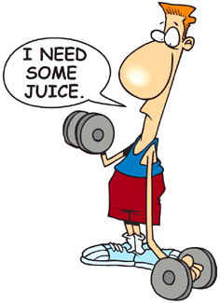
The stomach has been asleep. Give it time to wake up. Dumping a greasy bacon and eggs breakfast on a half-asleep stomach is a bad move? If you are not hungry, don't eat. You can take some fruit with you to eat later. Have a glass of herbal tea or some fresh made juice and your body will love you for it. If you are hungry, the best choice is fruit. It is easy to digest and will supply all the nutrition needed to start your day. Here are some suggestions that are easy to make and free of cholesterol and saturated fat.

Morning Mobilizer
One banana and one orange sliced into a bowl, then chilled for 10 minutes. A touch of honey and it's the perfect breakfast.

Grape-Pear, Day Starter
One pear diced, 10 seedless grapes and one frozen banana sliced over top. A tablespoon of frozen pineapple concentrate mixed, in will naturally sweeten to dish to a tantalizing treat.

Cereal Replacer
Hanging for that cold crunchy feeling of breakfast cereal. Here is a radical replacement for the usual breakfast of milk, starch and sugar. You need 2 shredded carrots, a quarter cup of raisins, rinsed then pick out any stems, and 1/4 can of frozen pineapple concentrate. Mix together in a bowl and leave in the fridge overnight. Ready to serve in the morning. Add of few sesame seeds and some frozen banana slices for extra flavor. Peel ripe bananas before freezing in freezer bags. Frozen bananas taste like ice cream. Kids love frozen bananas.

Cantaloupe Juice-Up
A great energizer to start the day. Rocket fuel for a weary body. A blast of beta-carotene, essential vitamins and minerals. Wear you running shoes to work.

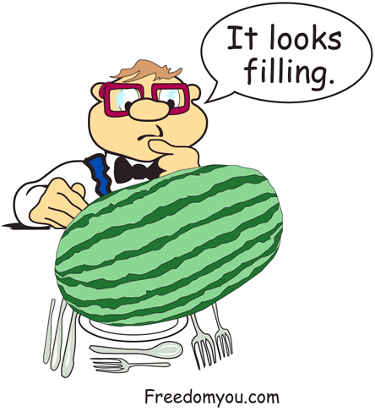
Carrot Juice

Coffee Kicker
Need that caffeine blast to get you going? We have one better. Ten carrots, 1 lemon, 1 apple and one beet. Get ready to hit overdrive. Your cells won't know what hit them.

Lunch Munch
Remember the backpack of calories your are carrying in every pound of fat. Your fat is screaming use me. A light lunch is the way to go. A small salad of fruits or veggies will met all you body's needs. It is hard to eat the right amount of food and chew it well, but you can do it. This is going to be fun. You don't have to eat till you feel stuffed. Who is in control, your belly or you? Eating a small lunch sends a message to your body to start the clean up process. A light lunch will give you more energy for the afternoon. Your mind will be clearer and you will get more done. Isn't that the way you want to live each day? If you give your cells what they need they will give you want you need …energy.

Super Salad
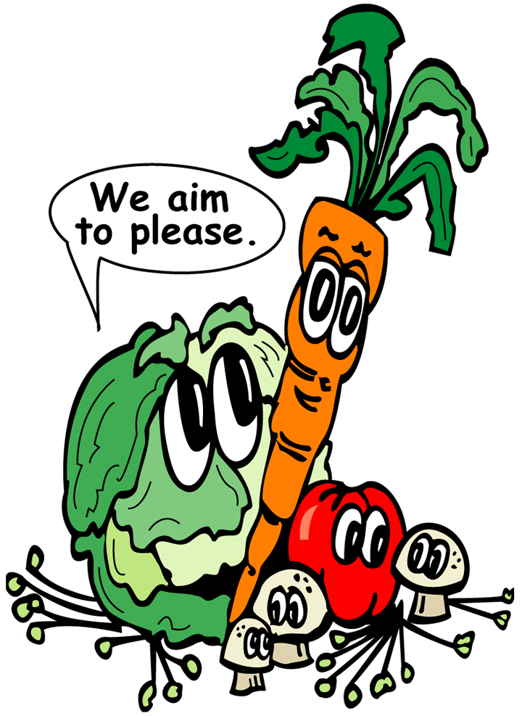
Carrots, yams, tomatoes, cucumbers, onions, any vegetables will work. The key is to dice them small or use a food processor. The dressing is the most important part. Store bought stuff is deadly. It is filled with transformed fatty acids that have been implicated with all sorts of diseases. The stuff is heated to 2000F°. It has as much nutrition as motor oil. Avocados make a great salad dressing. Natural fats and oils are good for you. They digest easily and supply natural fats and oils. Blend an avocado in a food processor or blender. Add cider vinegar, lemon juice, sea salt, a garlic clove, a slice of ginger, a teaspoon of honey and a small tomato. Experiment and you will come up with your own favorites. No junk on this salad just good nutrition for your cells. When you eat, you can almost hear them say thank you.

Cantaloupe

Surprise
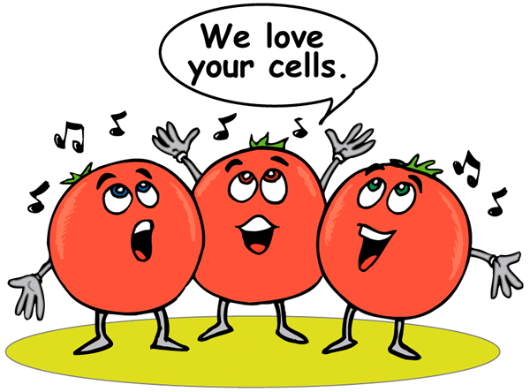
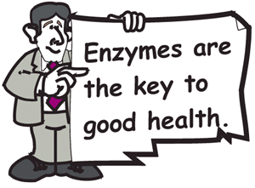
One cantaloupe diced and chilled in the freezer for ten minutes. That's it, the entire meal. Cantaloupe has the most nutrition per calorie of any food. It may take a little adjusting to think of a fruit as an entire meal, but try it and you will like it. If you prefer it a touch sweeter, add a teaspoon of honey over top. To lose weight, you need to cut calories while maintaining good nutrition; cantaloupes fit the need perfectly. Chew it well, enjoying all the flavor.

Cantaloupe Juice
One cantaloupe and 2 oranges fresh out of the juicer. A tropical milk shake abundant in life-giving nutrition. What and energy blast! The nutrition enters your blood in seconds. Carry a thermos to work if you cannot make it fresh. Drinking cantaloupe juice for lunch is a mini juice fast. It is filling and satisfying. Do not gulp it down but let it mix with your saliva, enjoying the subtle changes of flavor as digestive enzymes start their work in the mouth.

Winner Dinners
You're getting hungry. The stomach is growling. Anticipation is building. Time for major discipline. It is easy to overeat when you are hungry. The first thing you want to do when you get in the house is eat voraciously. Tell yourself you can eat later. Hunger is the build-up for a really enjoyable dinner. Try not to nibble, it is easy to eat a full meal one bite at a time. Have a hot shower or relax and clear your mind. A ten-minute prayer can recharge your spiritual battery. Put the day behind you, it is time to loosen up. The major work is done. Remind yourself of how well you are doing at controlling your diet. Feel content with your accomplishment. Remember how you used to live and feel revulsion for that lifestyle. You are winning a war against Goliath the stomach god. You are doing it, you can face hunger and win.

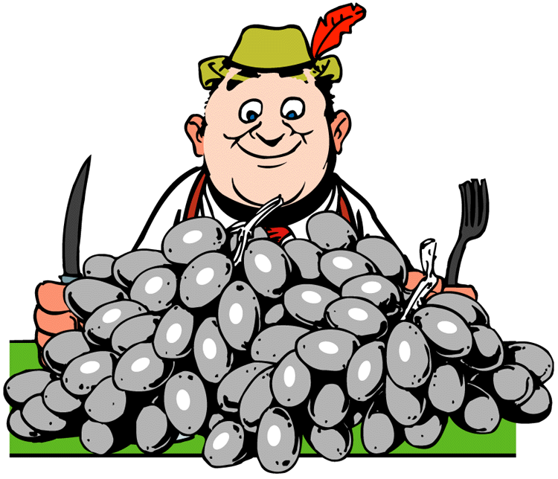
Grape Salad
Grapes, diced pears with slice of frozen banana. It may taste like dessert but it is a nutritious meal packed with vitamin C and enzymes. Your cells have never had it so good. Your blood is free form sticky fat, cholesterol and animal protein. The absence of additives is almost a shock. Like a bum having a bath and clean clothes after many months, you cells are happy.

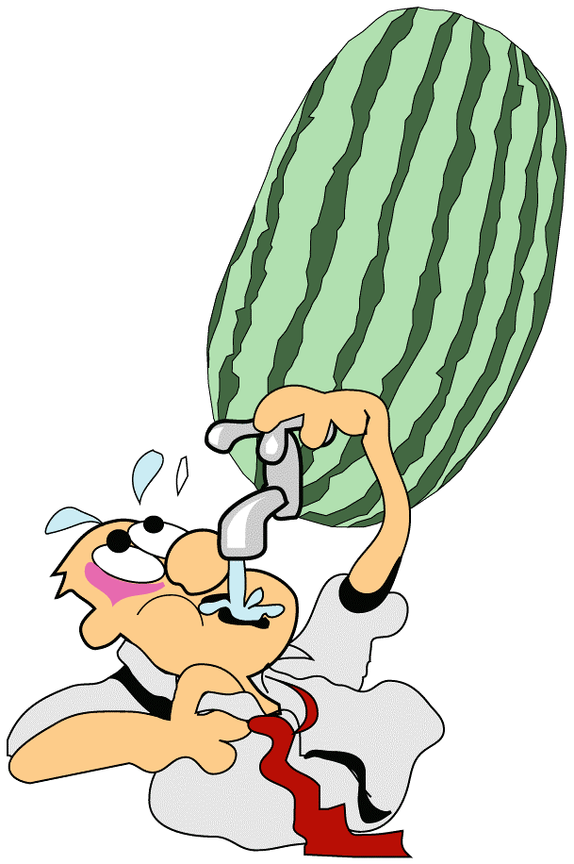Watermelon Meal
A watermelon really fills you up. You may feel fully satisfied with a hundred calories of watermelon filling your stomach. Sure, you'll be hungry a few hours later, but there will be more melon to eat. A greasy meal would have loaded you up with a 1000 calories. No more fried animal parts for this meal, you're in the Garden of Eden enjoying a melon. Can you hear those tropical bird singing?

Super Snack
TV boredom leads to the refrigerator. We stand with the fridge door open just not sure what to eat. Make the decision in advance. When you open the fridge, you will be staring at some veggies and a tub of avocado dip, or maybe a fruit salad or a frozen banana treat. If you are creative, you will eat the right thing for a snack.
Focus on eating. When we eat in front of the TV, the food vanishes from our plate and we are left unsatisfied. Be present when you eat. Sense the taste and how it feels in your mouth. You don't have to hurry. If you enjoy your snack, you will want to eat it again. An orange, grapefruit or melon makes a nutritious snack. It is difficult to overeat fruit. When you have had enough, you stop and feel satisfied. Not so with junk food, even when we're stuffed, we are still looking for something to fill the emptiness.

Raisin Nut Treat
Raisins, dates mixed with raw cashews, peanuts and almonds make a super snack. Loaded with healthy amino acids, essential oils, and minerals, you don't have to feel guilty about enjoying them.

Great Grapes
Wash grapes put them in a bowl in the freezer for 20 minutes. Nothing fancy but super healthy. If the acid of fruit is difficult to digest, try some yogurt over the fruit.

Get Juiced-Up
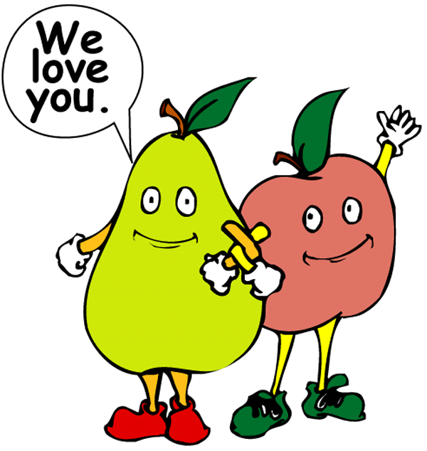
Fruit and vegetable juices cleanse, energize and regenerate the body. The nutrients are locked within their fibers. A juicer releases those nutrients with out digestive work. The juice has an abundant supply of vitamins, minerals and enzymes. Juicing creates a perfect environment for healing. Juice can replace any meal. It will help you lose weight, detoxify the body and give you an energy boost. Sure it takes some work to make juice, but the benefits are beyond price. You can't by health. As part of your 30-day program for overcoming compulsive eating, try to include some fresh-made juice every day. In our book God's Banquet Table, you will find many recipes to keep you on the straight and narrow path that leads to freedom.

Melon Power
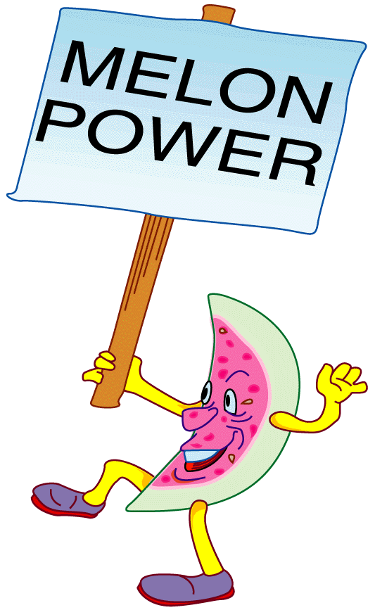
Melons are the best for making juice. They are easy to juice, inexpensive and combine well with pears, oranges, apples and grapes. More than a drink, it is a meal in a glass, fully satisfying and loaded with the high quality nutrition that your body needs.

Super V Eight
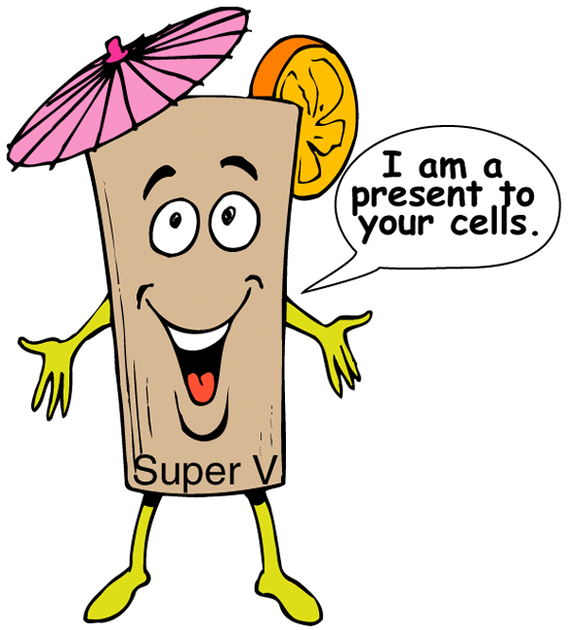
Carrots are the main ingredients for vegetable juice. Carrots are cheap and supply a good quantity of juice. They are also loaded with beta-carotene, which is important in the healing process. But, carrot juice by itself tastes terrible to most people. It is the mix of veggies that create the taste to blow your socks off. To carrots add beets, lemons, apples, garlic, radish, celery, yam, cucumber, and cider vinegar. Plain boring carrots become a 350-horse power V8 juice. Jet fuel for your cells, feeding them a wide spectrum of nutrients.

Super Blender

Recipes
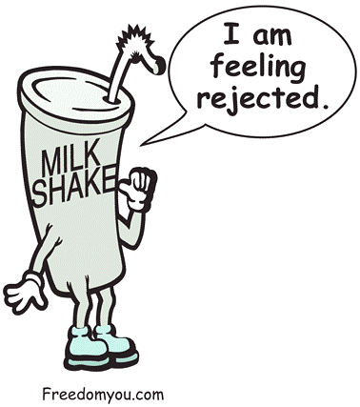Blender recipes are another way to make nutrition fun. We all love milk shakes but who want to eat an edible oil product. Bananas make an excellent base for fruit shakes, blend then add honey, cinnamon, pears, seedless grapes, oranges, kiwi, strawberries, dates, cantaloupe or whatever fruit your heart desires. Crushed ice thrown in the blender will chill the mixture.

Bibliography
Adler, Ronald B. & Towne, Niel. Looking Out Looking In, Harcourt Brace College Publishers, 6277 Sea Harbor Drive, Orlando, FL 32887-6777, 1996.
Alexander, David Stewart. Spiritual Abundance, Jeremy P. Tarcher / Putnam, 200 Madison Ave., New York, NY, 10016, 1997
Beibel, David. If God is So Good Why do I Feel So Bad, Fleming H. Revell, P.O. Box 6287, Grand Rapids, MI 49516-6287, 1989.
Bright, Deborah. Creative Relaxation, Ballantine Books, New York, NY, 1989.
Burns, David D. Feeling Good, The New Mood Therapy, Penguin Books USA Inc. 350 Hudson St., New York, New York, 10014, 1980
Canfield, Jack & Hansen, Mark Victor. A 2nd Helping of Chicken Soup for the Soul, Health Communications Inc. 3201 S.W. 15th St., Deerfield Beach, FL, 33442-8190, 1995.
Foa, Edna B. and Wilson, Ried. Stop Obsessing,Bantam Books, 1540 Broadway, New York, NY, 10036, 1991
Forward, Susan. Toxic Parents, Bantam Books, 1540 Broadway, New York, New York, 10036, 1989.
Keirsey, David & Bates, Marilyn. Please Understand Me, Prometheous Nemesis Book Company, Post Office Box 2748, Del Mar, CA 92014, 1984.
Luciani, Joseph J. Healing Your Habits, Laura Media, 7060 Miramar Rd., Suite 104, San Diego, California, 1990.
MacDonald, Gordon. Restoring Your Spiritual Passion, Oliver-Nelson Books, Nashville Tennessee, 1986.
Matthews, Andrews. Being Happy, Price Stern Sloan Inc., 11150 Olympic Boulevard, Suite 650, Los Angeles, California 90064, 1988.
Matthews, Andrews. Making Friends, Price Stern Sloan Inc., 11150 Olympic Boulevard, Suite 650, Los Angeles, California 90064
May, Gerald G. Addiction & Grace, Harper & Row Publishers, Inc., 10 East 53rd Street, New York, NY, 10022, 1988.
Mckay, Matthew, Davis, Martha, Fanning, Patrick Thoughts & Feelings, The Art of Cognitive Stress Intervention, New Harbinger Publications, 5674 Shattuck Ave. Oakland, CA 94609, 1981
Miller, Kieth J., A Hunger For Healing, HarperCollins, 10 East 53rd Street, New York, NY 10022, 1992.
Shelmon, Barbara Leahy. Healing the Hidden Self, Ave Maria Press, Notre Dame, Indiana, 46556, 1982
Swindoll, Charles R. Encourage Me, Zondervan Publishing House, Grand Rapids, Michigan 49530, 1982.
Toropov, Brandon. The Art of Dealing With People, Paramus, New Jersey, 07652, 1997.
Twerski, Abraham J. Addictive Thinking, Hazelden, City Center, Minnesota, 55012-0176,1990. (Http//www.hazelden.org)
Wegscheider, Sharon. Learning to Love Yourself, Health Communications, Inc., Deerfield Beach, Florida, 33442, 1987.
Whitfield, Charles L. Healing the Child Within, Health Communications Inc. Enterprise Center, 3201 South West 15th. St. Deerfield Beach, Florida, 33442, 1987. Zimbardo, Phillip G. Psychology and Life, Foresman and Company, Glenview, Illinois, Dallas, TX, 1976.
Wilson, Anne Schaef & Fassel, Diane. Addictive Organization, HarperCollins (one word) 10 East 53rd Street, New York, NY, 10022, 1990.
Simon and Shuster - www.phdirect.com

